How to choose which HTP firmware I need

## Scenario of potential confusion for our customers:

The radio will display that error if it is not the appropriate firmware upgrade file. The HTP-900RE and the HT-P have different files, those product families can easily be confusing. I have below is an image that illustrates the different enclosures for the two similarly named product families.

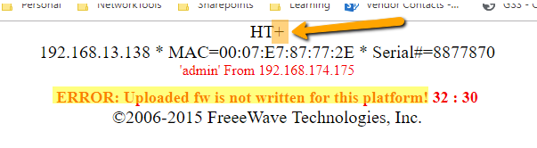

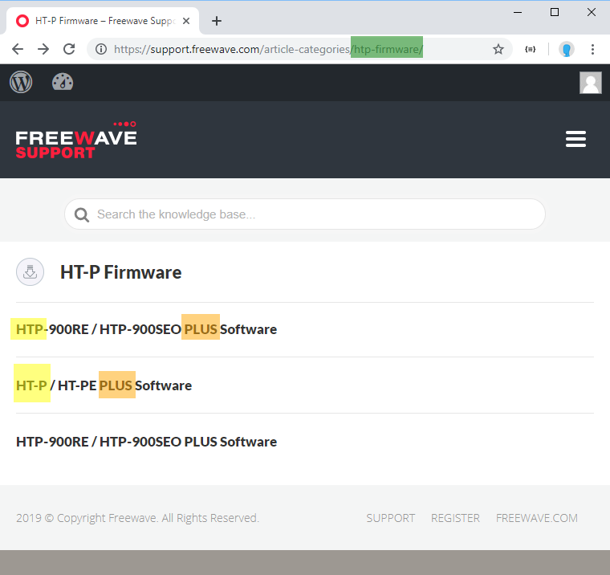

# HTP-900RE top versus HT-PE bottom:

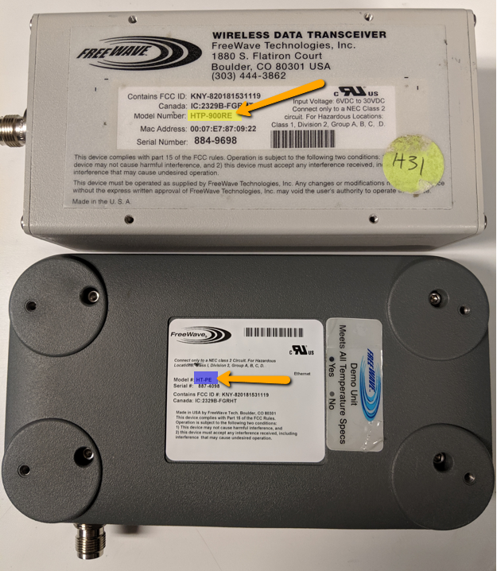

The radio will display that error if it is not the appropriate firmware upgrade file. The HTP-900RE and the HT-P have different files, those product families can easily be confusing. I have below is an image that illustrates the different enclosures for the two similarly named product families. I looked up the serial # in your screen shot (887-7870), and it is a model **HTP-900RE**.

HTP-900RE did not have a firmware version 3.04; instead it went from 3.01 to 3.05 (page 2 of the attached ‘HTP-900RE-900SEO Release Notes.pdf’). HT-P had the firmware version of 3.04.

## **Correct** (upgrade firmware file sent as a separate email from ‘Hosted~FTP~ [ftp@hostedftp.com](mailto:ftp@hostedftp.com)’):

HT+\3.14\ **HT-900**_3.14

## Incorrect (will result in an error):

HT-PE\HT-P_3.14