Install Zentry Client
Purpose: To get the Zentry zero trust edge tunneller installed onto your devices. This guide will cover installation on all operating systems compatible with the Zentry client. These include Windows, MacOS, iOS, Android, Linux, and Docker.

Minimum System Requirements:
- 12MB (112MB or more to better accommodate default logging level)
- 32MB Ram
- Admin/Sudo privileges for installation

Windows Zentry Client Install
- Navigate to: https://github.com/openziti/desktop-edge-win/releases
  - Scroll down until you find the latest release.
  - Click the release version
  - Scroll down until you find the section “Assets”
  - Choose the first .exe file (Ziti.Desktop.Edge.Client-<version>.exe
    - You can download the sha256 string and verify the download is sage.
      - Open powershell
      - Type command: Get-FileHash -Algorithm SHA256 “C:\path\to\the\executable"
      - Compare the output to the sha256 string you copied from the GitHub page.
  - Open your file system and double-click on the client installer (.exe)
- Follow the installation wizard
  - Note: you need Administrator permissions for this install
- After installation is complete you can find the application running as a background process.
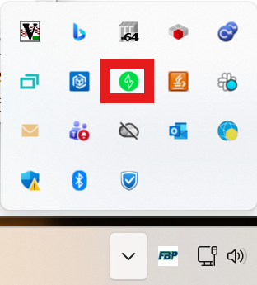
- When the icon is “green” that means the client is running and the ziti interface is up.
- When the icon is “red” that means the client is not running and the ziti interface is no longer present.
  - This would make it so you are not able to communicate with other devices on the zero trust network.
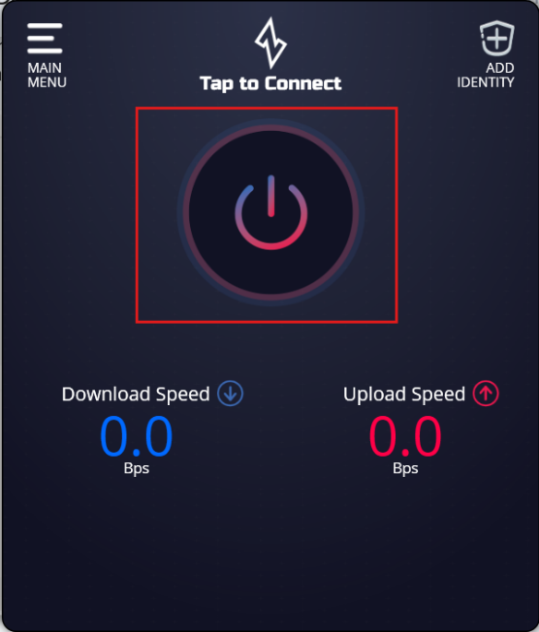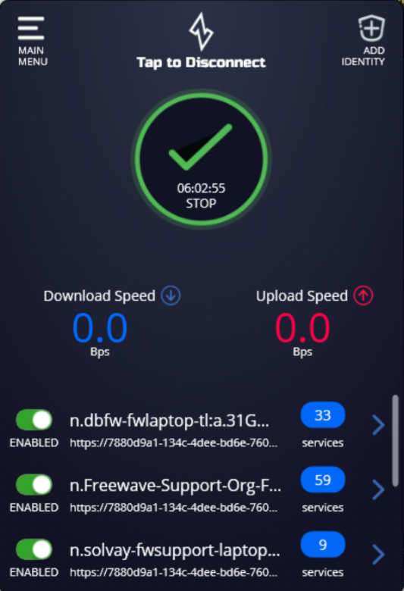
- You can turn the client application on by clicking the power icon with your cursor on the application GUI.
- That completes the installation of the Zentry client for Windows.

MacOS Zentry Client Install
- Open your AppStore app on your Mac
  - You can also find the application via a web browser: https://apps.apple.com/us/app/ziti-desktop-edge/id1460484572?mt=12
    - This will prompt you to open the AppStore
- Search for “Ziti Desktop Edge”
- Choose to install
- Once installation finishes open the app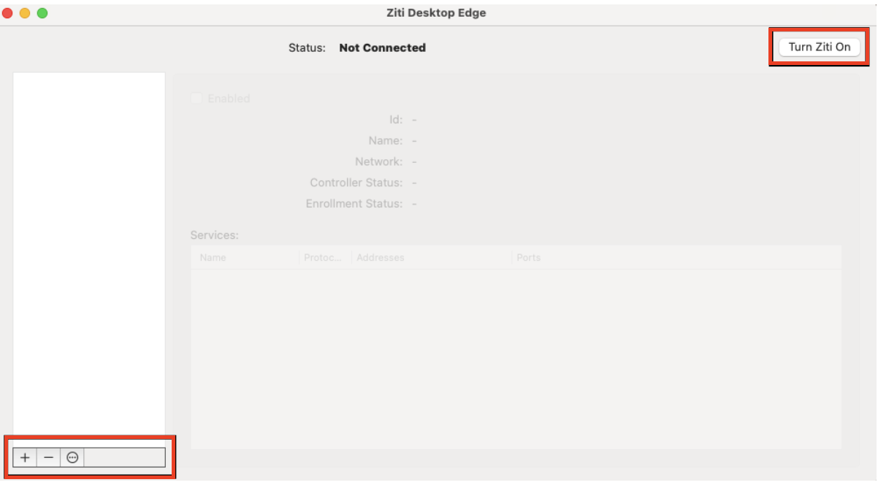
- Turn the client on
- You will use the “+” icon in the bottom right corner to add your identities.
- This completes your installation of the Zentry client.

iOS Zentry Client Install
- Open your App Store app
- Search: Ziti Mobile Edge
- Install the client
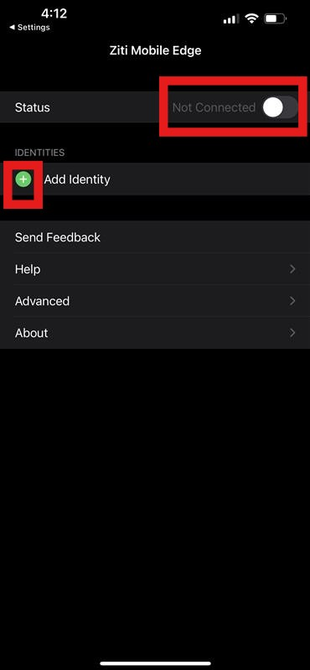
- Ensure the client is turned on
- Use the “Add Identity” to enroll identities onto this device.
- This completes the installation of the Zentry client on iOS

Android Zentry Client Install
- Open your Google Play app
- Search: Ziti Mobile Edge
- Install the client
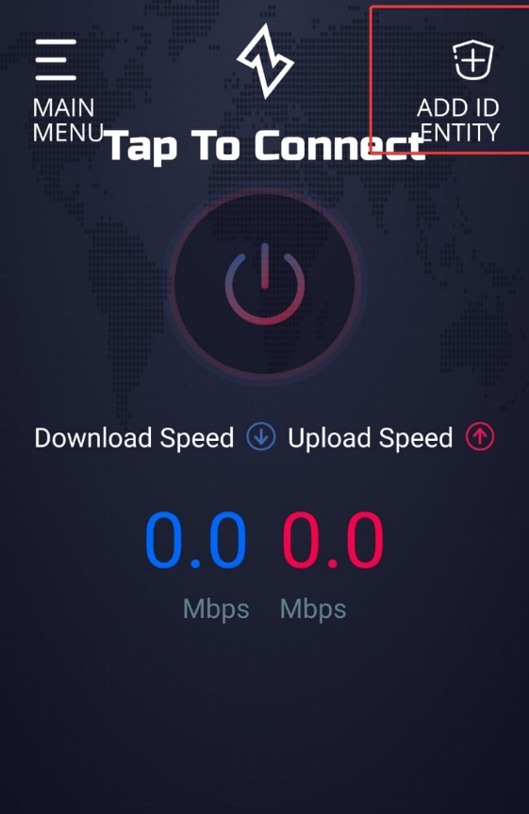
- Use the center power icon to turn the client on and off.
- Use the “Add Identity” option in the top right corner to add identities to this device.
- This completes the install of the Zentry on Android.

Linux Zentry Client Installation
It is recommended to install the Zentry client using the package manager associated with your distribution. Installing via package manager:
- Client installed and a systemd service is created
- Proper permissions and policies are created for the client. This ensures the client is run as a non-root user.
- Enrollment of an identity and the cleanup of the enrollment is handled by the package manager install.
- Allows for easier upgrades to newer versions of the client.
Ubuntu:
- Available Architectures:
  - X86_64
  - Arm64
- Run command:
  - curl -sSLf https://get.openziti.io/tun/scripts/install-ubuntu.bash | bash
- Then use scp to transfer the .jwt file to the intended device
  - Windows:
    - scp “C:\location\to\jwt” <target-device-username>@<host-ip>:~/
  - Linux:
    - scp “/location/to/jwt” <target-device-username>@<host-ip>:~/
  - Note: depending on your permissions copying the jwt to any directory other than the home (~/ OR /home/<username>) directory of a Linux device will be blocked.
- Then you will move the .jwt from the location the file was copied to during the scp command to the appropriate Zentry client identities directory.
  - ssh into the intended device:
    - ssh <username>@<host-IP>
    - enter password
  - Run command ‘ls’ to confirm .jwt file is present in the home directory.
  - Run command:
    - (sudo) mv <filename.jwt> /opt/Openziti/etc/identities/
- Now run the client by starting the systemd service.
  - sudo systemctl enable --now ziti-edge-tunnel.service
- Check that the client is up and running successfully.
  - sudo systemctl status ziti-edge-tunnel --no-pager -l
  - You should see an output similar to:
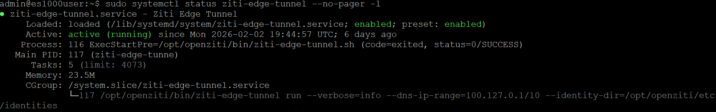
- The status in the screenshot above indicates that the client is running as expected.
- This concludes the installation of the Zentry client on Linux Ubuntu.
Debian:
- Available Architectures:
  - x86_64
  - arm64
  - armhv7
- First you must add the openziti package repository to your sources.list.d directory.
- Depending on the Debian version you are running will impact what command you run to add the repository to the sources list.
Debian | Ubuntu_LTS | Archs
13 Trixie | jammy | x86_64, arm64
12 Bookworm | jammy | x86_64,arm64
11 Bullseye | focal | x86_64, arm64
10 Buster | bionic | x86_64, arm64, armhv7

- You will enter the Ubuntu_LTS value associated with the Debian version you are using.
  - Ex: echo "deb [signed-by=/usr/share/keyrings/openziti.gpg] https://packages.openziti.org/zitipax-openziti-deb-stable jammy main" | sudo tee /etc/apt/sources.list.d/openziti.list >/dev/null
- Run command:
  - echo "deb [signed-by=/usr/share/keyrings/openziti.gpg] https://packages.openziti.org/zitipax-openziti-deb-stable <Ubuntu_LTS name> main" | sudo tee /etc/apt/sources.list.d/openziti.list >/dev/null
- Then you will install the package signing pubkey.
- Run command:
  - curl -sSLf https://get.openziti.io/tun/package-repos.gpg | sudo gpg --dearmor --output /usr/share/keyrings/openziti.gpg
- Now update your package manager
- Run command:
  - sudo apt update
- Then install the client
- Run command:
  - sudo apt install ziti-edge-tunnel
- After the install is complete you will need to transfer the .jwt file to the intended device.
- Then use scp to transfer the .jwt file to the intended device
  - Windows:
    - scp “C:\location\to\jwt” <target-device-username>@<host-ip>:~/
  - Linux:
    - scp “/location/to/jwt” <target-device-username>@<host-ip>:~/
  - Note: depending on your permissions copying the jwt to any directory other than the home (~/ OR /home/<username>) directory of a Linux device will be blocked.
- Then you will move the .jwt from the location the file was copied to during the scp command to the appropriate Zentry client identities directory.
  - ssh into the intended device:
    - ssh <username>@<host-IP>
    - enter password
  - Run command ‘ls’ to confirm .jwt file is present in the home directory.
  - Run command:
    - (sudo) mv <filename.jwt> /opt/Openziti/etc/identities/
- Now run the client by starting the systemd service.
  - sudo systemctl enable --now ziti-edge-tunnel.service
- Check that the client is up and running successfully.
  - sudo systemctl status ziti-edge-tunnel --no-pager -l
  - You should see an output similar to:
- The status in the screenshot above indicates that the client is running as expected.
- This concludes the installation of the Zentry client on Linux Debian.
Linux Zentry Client Notes
- The Zentry client ideally uses system-resolved to manage the zero-trust traffic.
  - If you do not have system-resolved installed and running, you can manage the resolv.conf file manually.
  - The ziti-edge-tunnel will write the nameserver used by the ziti0 interface to intercept and forward the traffic for the Zentry network.
    - This can break the devices’ ability to normally connect to the internet.
    - Fix this by opening the resolv.conf file in a text editor of your choice and add a nameserver that keeps the device able to resolve non-Zentry traffic and keep the Zentry client online.
    - Run command:
      - Sudo nano /etc/resolv.conf
      - Add line: nameserver 8.8.8.8 (or whatever DNS server you prefer)
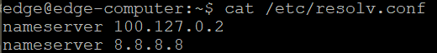
  - Then to prevent resolv.conf from being overwritten you can make resolv.conf immutable.
    - Run command:
      - sudo chattr +i /etc/resolv.conf
    - This makes the resolv.conf file read-only.
    - To make changes to this file you will have to make it editable again.
    - Run command:
      - sudo chattr -i /etc/resolv.conf
- The ziti0 interface may be recognized by your primary network manager application (NetworkManager, Netplan, etc) but this interface is unmanaged.
  - There can still be an issue with resolving Zentry traffic if the nameserver is not present.
  - For example, you may have all the above configured properly, but Zentry traffic is not resolving correctly. This may be due to the DNS server not being bound to the ziti0 interface. You can fix this by adding the nameserver to the ziti0 interface using resolvectl cli tool.
    - Run command:
      - resolvectl
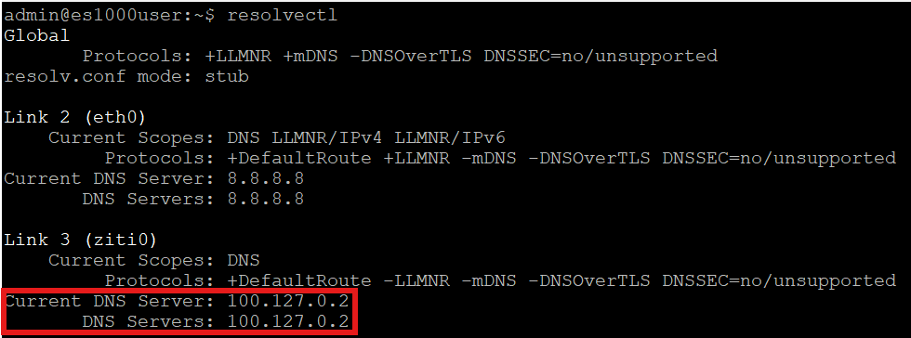
    - You will want to see the DNS server IP address populated under the ziti0 interface.
  - If you do NOT see the DNS server IP address present, you can add it manually.
    - Run command:
      - sudo resolvectl dns ziti0 <DNS IP Address>
      - You can find the ziti0 DNS server by checking the .service file or the .env file
        - checking DNS server by .service file:
          - sudo cat /lib/systemd/system/ziti-edge-tunnel.service
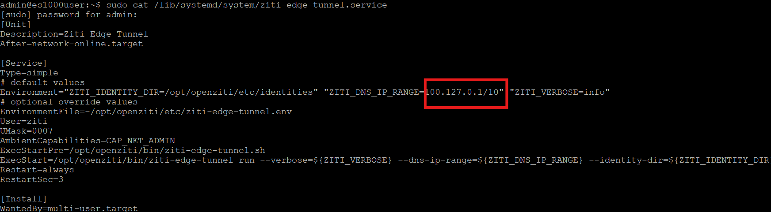
        - checking DNS server by .env file:
          - sudo cat /opt/openziti/etc/ziti-edge-tunnel.env
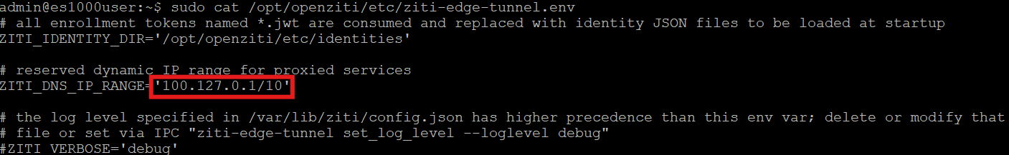
  - Note: the default ZITI_DNS_IP_RANGE is 100.64.0.1/10. This value can be changed to meet user use-case preferences. The important thing to remember is if this interface subnet overlaps with existing subnets in your network you may break the Zentry clients’ ability to communicate over the Zentry network.
- There are some cli tools you can use to ensure the device can resolve Zentry records.
  - gentent
    - Run command:
      - getent hosts <Zentry-Function-Name>
    - Ex:
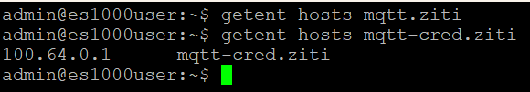
    - If you see do NOT see an output from the command, then your device is not hosting a function with the intended name OR does NOT have permission to access the function hosted on another device.
    - This can also indicate that the configuration of the ziti0 interface and associated DNS server parameters are not proper.
    - If you DO see an output, then this indicates the ziti0 interface is properly intercepting Zentry traffic.
  - nslookup
    - Run command:
      - nslookup <Zentry-Function-Name> <DNS Server IP>
    - Ex:
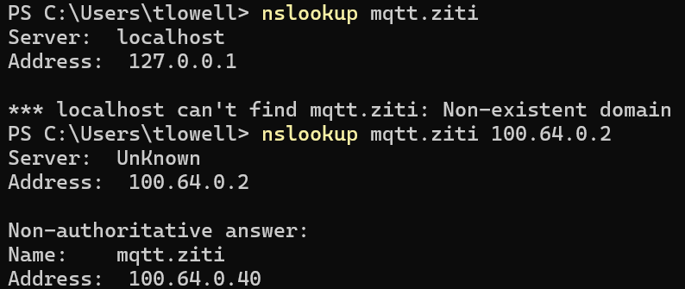
    - If you do NOT provide a DNS server IP, then the localhost interface will likely be used by default
    - If you do provide the appropriate DNS server IP, then you should get an output similar to the above example.

Docker Zentry Client Installation
When running the Zentry client in a docker container there are a couple different ways to run the container.
- openziti/ziti-host image
  - hosting only without proxy or nameserver
  - mainly for server-side hosting (binding) of specific services with minimal privileges and no proxying of outbound traffic
- openziti/ziti-edge-tunnel image
  - transparent proxy DNS nameserver
  - mainly for client-side access (dialing services) with full network transparency.
The option you choose will depend on your particular needs. Typically, if you are going to be forwarding traffic to device in the LAN of the device running the ziti-edge-tunnel via docker you will use option two. If the device that is running the image is the device you will be reaching services from (i.e. ftp, web GUI, etc.) then you will use option one.
There are several options for running the container. You may use standard file path mounting in the docker run command, you may use docker compose file, and a combination of these with a volume. If you have access to the file system of the device running the container then using standard file path mounting is sufficient. If you do NOT have access to the host device file system/cli then you may want to use docker compose.
For rare situations where you do not have access to any of the host device file system or cli you can build a docker image that has an identity/jwt already baked into the image. When this image is ran the jwt will be enrolled or start the verification process with the Zentry controller if the identity is already enrolled. For assistance on this path please contact support@freewave.com

Option 1 Run ziti-host Image:
- docker run -d --name ziti-host --restart unless-stopped --pull always -e ZITI_ENROLL_TOKEN=”/absolute/path/host.identity.jwt” -v ziti_host_id:/ziti-edge-tunnel openziti/ziti-host:latest run-host --identity-dir /ziti-edge-tunnel --verbose 3 --refresh 10
Option 2 Run ziti-edge-tunnel image:
- docker run -d --name ziti-edge-tunnel --restart unless-stopped --network host --cap-add NET_ADMIN --device /dev/net/tun -e ZITI_ENROLL_TOKEN="/absolute/path/intercept.identity.jwt" -v zet_id:/ziti-edge-tunnel openziti/ziti-edge-tunnel:latest run --identity-dir /ziti-edge-tunnel --verbose 3 --refresh 10 --dns-upstream 1.1.1.1 --dns-ip-range 100.64.0.1/10

- regardless of the option you run the Zentry client container, you can check the logs by:

  - Run command:
    - docker logs -f ziti-host
    - docker logs -f ziti-edge-tunnel
    - the name you put after the “-f” flag is the name of the container.
  - If you do not have CLI access then look for a log’s icon in the GUI where you ran the docker run command.
- There may be other configurations that must be made on the device hosting the docker container like adding the appropriate DNS servers to the host device.
  - you can enter the whole subnet of the “dns ip range” (100.64.0.1/10) if the device allows for that type of notation.
  - You can enter each DNS IP per function hosted on the device. you find this by using the “getent hosts <function-name>” or “nslookup <function-name>
  - <dns server>” commands, which will show the DNS IP associated with that function. The “<dns server>” in the nslookup in the case would be 100.64.0.2.
    - Ex: getent hosts mqtt-cred.ziti
    - Ex: 100.64.0.10 mqtt-cred.ziti
    - The 100.64.0.10 is the DNS IP the mqtt-cred.ziti is bound to for traffic flow.
    - Note: this value is not static and can change as other functions are hosted or accessible from the host device.
    - Note: Typically, the last octet of the DNS subnet range increments by one for each function added to the identity.
      - Ex: if you have 5 functions being hosted by an identity (device running docker ziti-edge-tunnel) then each function will get bound to 100.64.0.2 plus one in the last octet: 100.64.0.3=Function1, 100.64.0.4=Function2, 100.64.0.5=Function3, and so on.
- This concludes the installation of the Zentry client using Docker.

