Non-Zentry Identity Dialing Service via ES1000 Guest VM
Purpose: To allow a device, that is not able to host a Zentry agent, dial (connect to) a service hosted on another device to communicate with a device in the LAN that is also not able to run the Zentry agent.
- Ex: PLC requesting Modbus data from RTU at a remote site.
  - PLC and RTU are not capable of running the Zentry Agent
  - Both PLC and RTU have a Zentry Enabled device as their gateway
  - PLC sends a Modbus request; The Zentry enabled gateway for the PLC intercepts the dial request for a Zentry Fabric Service
  - Zentry enabled gateway for the RTU receives incoming connection request and forwards the request onto the RTU
  - Request is fulfilled and the PLC receives the data from the initial request.

Required Tools/Items:
- 2x ES1000s (or BYOD that is capable of running Zentry agent)
  - Required minimum ES1000 firmware version: v1.09
- Automation equipment (PLC, RTU, etc.)
  - Using software emulators is recommended for bench testing prior to deploy
- Zentry Account
- Laptop/Desktop

Procedure
Setup Guest OS [Debian container]:
- Log into your ES1000 web GUI
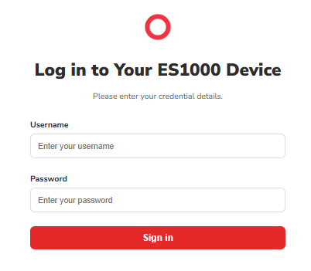
- If your ES1000 firmware version is v1.09 navigate to the System tile
  - Newer firmware versions created a User OS tile at the main dashboard
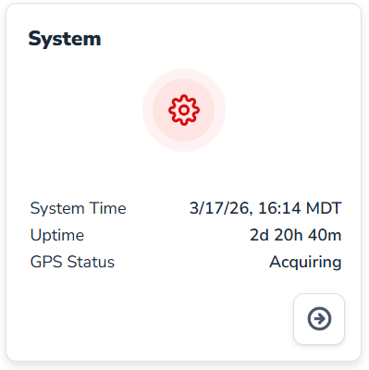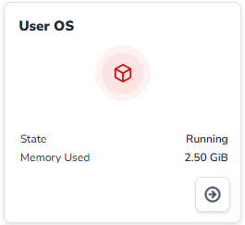
- If you have not set up the User OS then do so now. Click the “+ Setup” button and follow the setup prompts.
  - There are two images you can choose from currently. One has Node Red natively installed and the other does not.
  - If you plan on communicating with devices via the ES1000 rj45 serial ports via the user OS space, you must use the Node Red image.
  - Once the user OS is running you should see something similar what is shown below.
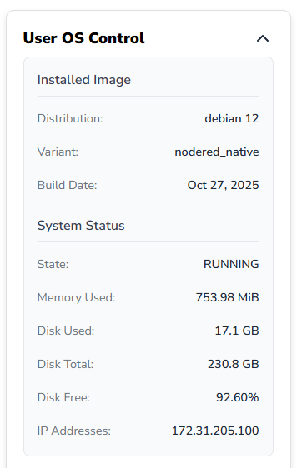
  - The GUI may differ depending on the ES1000 firmware version
  - Take note of the IP address associated with the container. This IP will be used to initially access the container.
- In order to access the user OS a service must be hosted on the ES1000 that forwards to the Debian container.
  - This is all done via a command line interface (CLI)
- Navigate to https://zentry.freewave.com and login to your Zentry console organization.
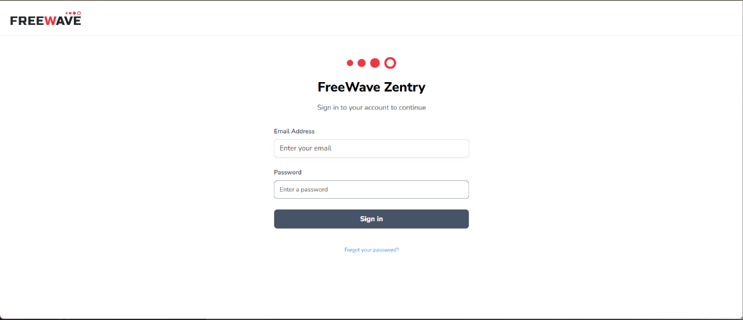
- Navigate to the ES1000 you have the user OS running
- Choose “+ Host a Function on the Device”
- Provide entries for Service Name, Forward Host, and Ports
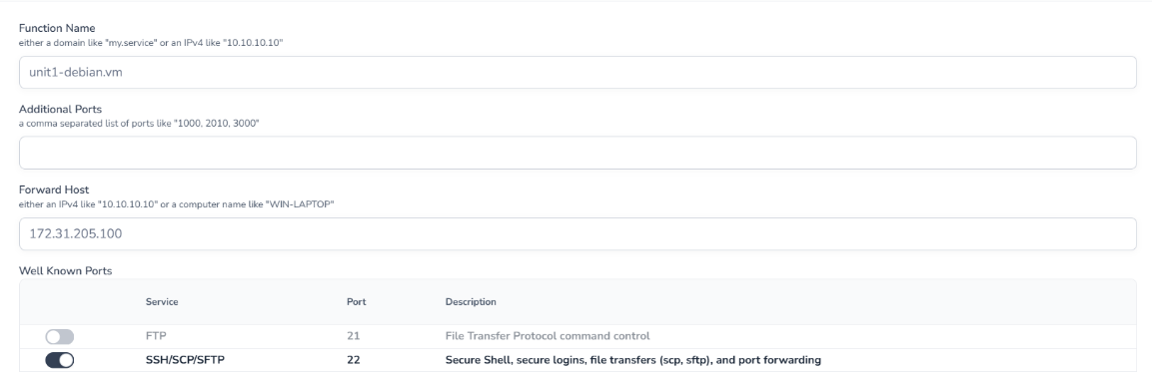
- Save the Service
- Choose “+ Add Identity to Service”
- Add your laptop
- Copy the Service name and open a terminal or terminal emulator
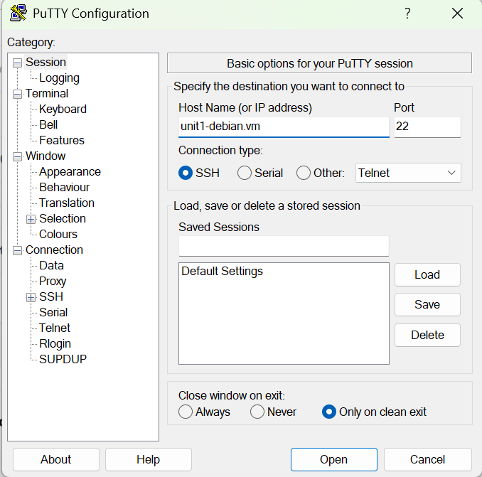
- Paste the Service name into the emulator
  - If using a terminal, enter command:
    - ssh <username_of_userOS>@<userOS_Container_IP>
- Enter the user credentials created when you setup the container.
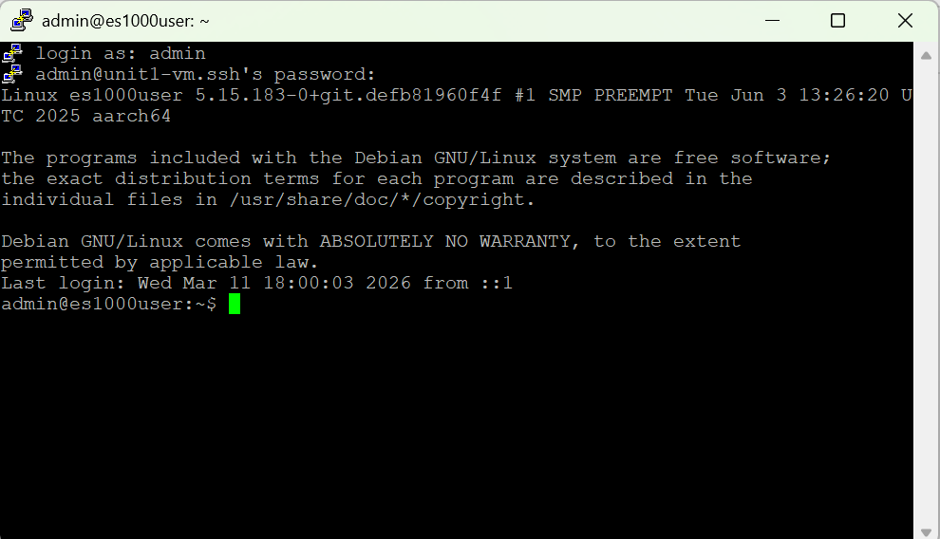
- You can now start configuring the user OS.
Install Zentry Agent:
- SSH into the user OS
- Perform the following commands:
sudo apt update

sudo apt install rinetd net-tools

echo “deb[signed-by=/usr/share/keyrings/openziti.gpg] https://packages.openziti.org/zitipax-opensiti-deb-stable jammy main” | sudo tee /etc/apt/sources.list.d/openziti.list>/dev/null

curl -sSLf https://get.openziti.io/tun/package-repos.gpg | sudo gpg --dearmor --output /usr/share/keyrings/openziti.gpg

sudo chmod -c +r /usr/share/keyrings/openziti.gpg

sudo apt update

sudo apt install ziti-edge-tunnel

- Now an identity for the user OS must be created
- Navigate to https://zentry.freewave.com
- Log in and go to Devices > Org Devices
- Choose to “+ Add Organization Device”
- Once the identity is created, download the token
- Open a terminal to use SCP (secure copy protocol) to transfer the token to the user OS
scp /path/to/token.jwt <user>@<service_name>:~/

EXAMPLE:

scp "C:\Users\tlowell\Downloads\give-it-a-meaningful-name.jwt" admin@debian-vm.ssh:~/
- Back in the terminal of the user OS SSH session enter command
admin@es1000user:~$ ls
- You should see the .jwt file in the output
- Now move that file to the proper location
admin@es1000user:~$ sudo mv give-it-a-meaningful-name.jwt /opt/openziti/etc/identities/
admin@es1000user:~$ sudo systemctl enable –-now ziti-edge-tunnel
admin@es1000user:~$ sudo systemctl status ziti-edge-tunnel –-no-pager -l
- You should see an output that looks something like:
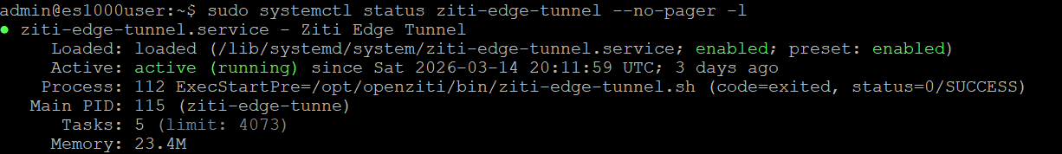
- You can now start hosting services on the identity you created for the user OS.
Configure rinetd:
- You are now going to edit the rinetd configuration file
- This tool allows you to route traffic
  - This will allow non-Zentry-enabled devices’ traffic to be picked up by the Zentry agent running in the user OS
- Open the rinetd configuration file in a text editor in the user OS SSH session you are logged into.
admin@es1000user:~$ sudo nano /etc/rinetd.conf
Input the desired configuration
  - You will do this for any port you need to have intercepted
0.0.0.0 <port> <service-name> <port>
  - Ex: if you want to intercept modbus traffic you will enter:
    - 0.0.0.0 502 my-modbus-service.mb 502
- Perform ctrl-O, then hit “enter” to save the edit
- Perform ctrl-X to exit the editor
- Perform sudo systemctl restart rinetd
Configure ES1000 Firewall:
- Navigate to the Firewall tile in the ES1000 web GUI
- Click the “gear” symbol to add or edit rules.
- For each rinetd entry in the rinetd.conf you want to add a port forward rule under the “User OS Port Forwarding” section.
  - Keeping with the port 502 example ensure you have a rule indicating which interface traffic should be forwarded from.
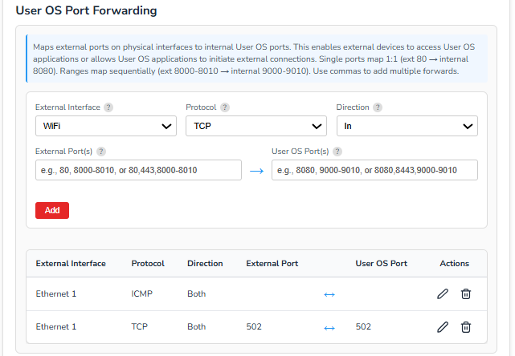
  - It is also recommended to add an ICMP rule so you can do PING diagnostics to devices in the LAN and ping from the LAN to the user OS space.

Example Wire Frame of Configuration

