Remote FGR Serial Radio Monitoring & Configuration via Zentry

- Needed Items
  - FGR Serial network
  - Tool suite
  - Zentry Client installed on Laptop running Tool Suite
  - Identity for Laptop
  - Edge device capable of running Zentry Client
  - Identity for Edge device
  - Data Cable for FGR (Part Num:ASC3610DJ)
  - DB9 to RJ45 Serial Cable (Part Num:ECD2408ED)
  - Serial to Ethernet converter (terminal server)
  - Zentry Organization Account

What the Configuration Looks like…
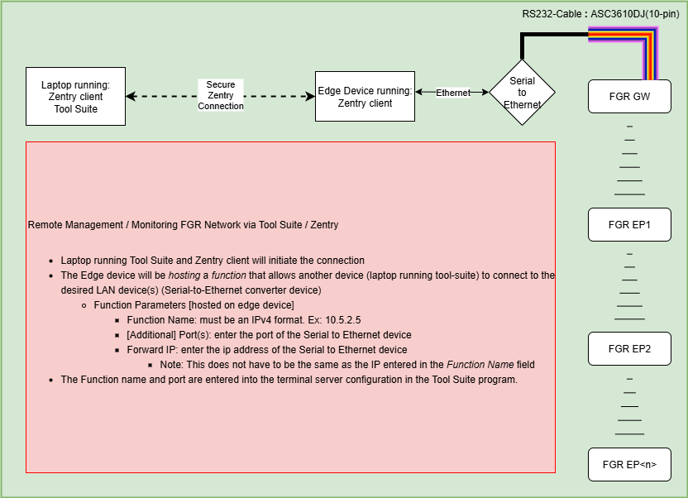

Install Zentry Client
- Please refer to: <link to doc “install Zentry client”> to install the Zentry Client on your laptop or the device you will use to connect to the radio network gateway via Tool Suite.
Install Tool Suite
- Visit https://support.freewave.com/hc/en-us/articles/10908081258900-FGR3-CE-C-Serial-Radios to download the latest version of Tool Suite.
Configure Tool Suite
- When you first open Tool-Suite you will be presented with a screen as shown below.
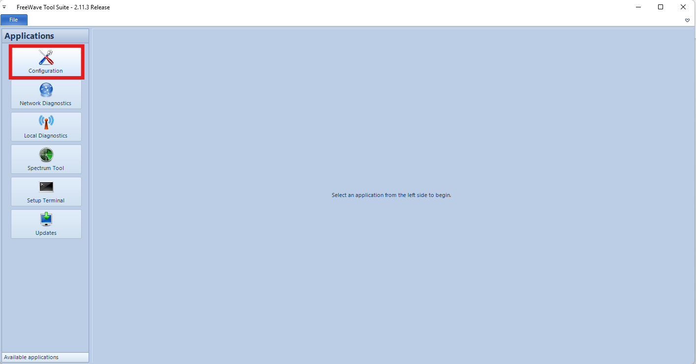
- Click on Configuration
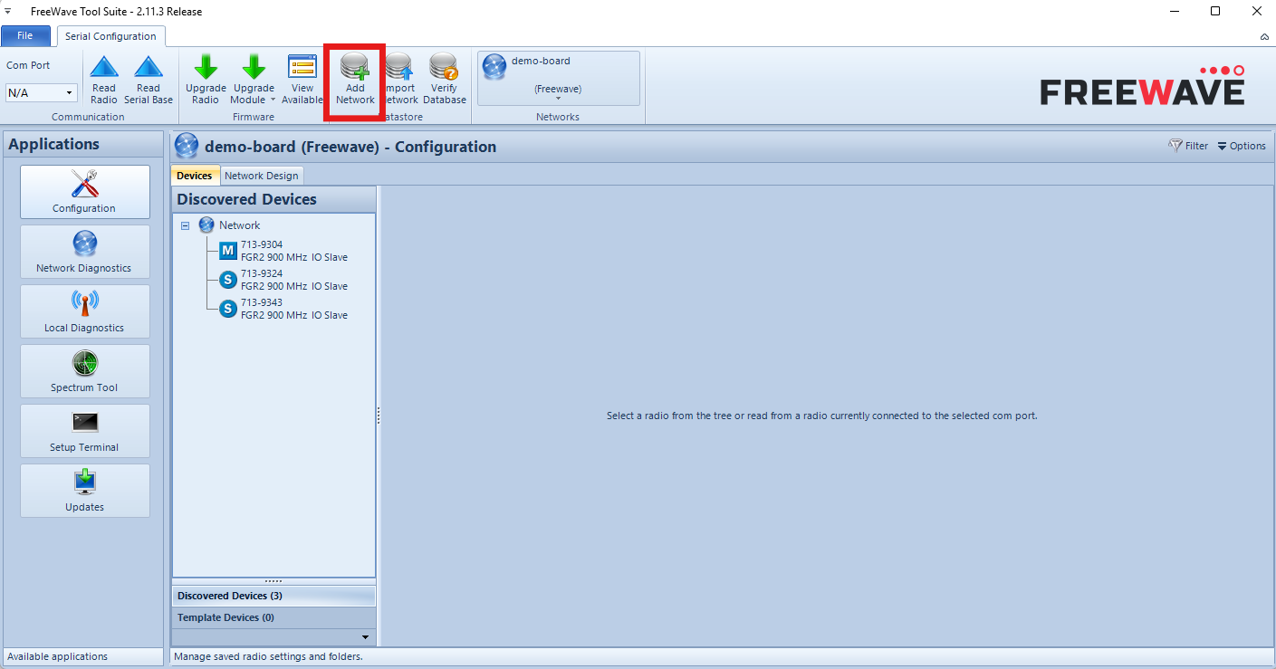
- Click on Add Network
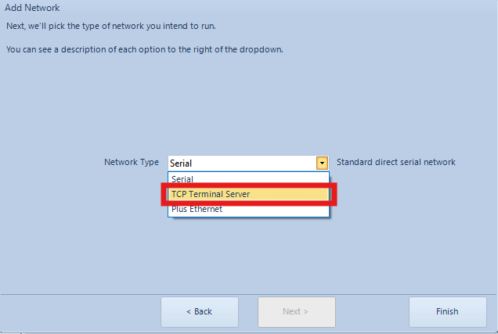
- Enter in the necessary fields on the first page.
- When selecting Network Type make sure to choose TCP Terminal Server
- Then click Finish
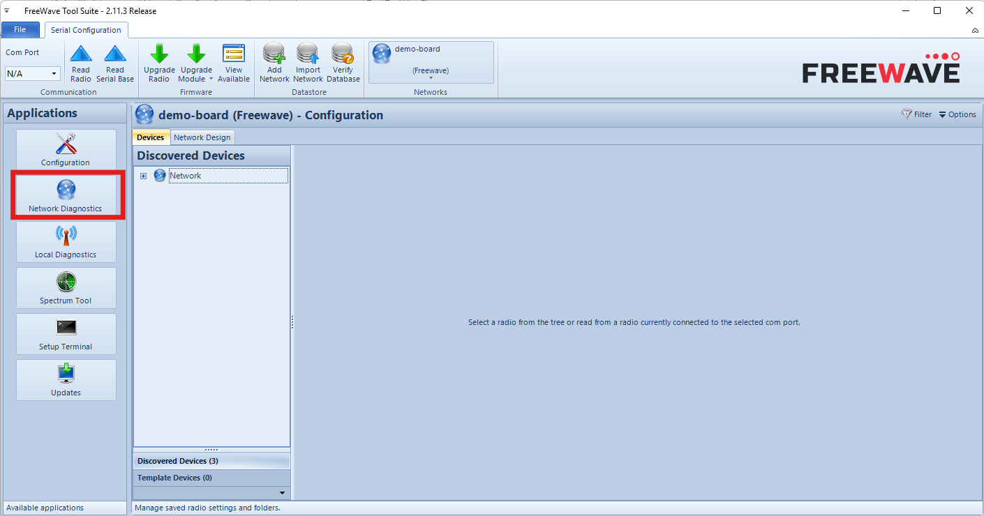
- Click Network Diagnostics
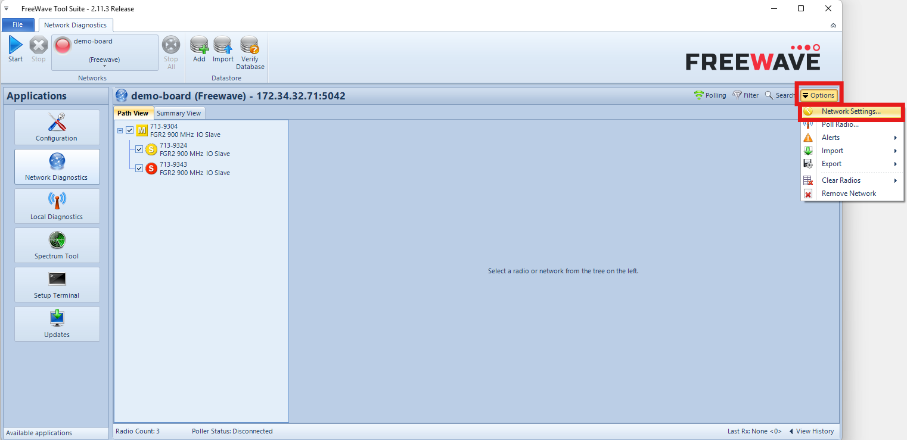
- On the right-hand side of the window, choose Options, then Network Settings…
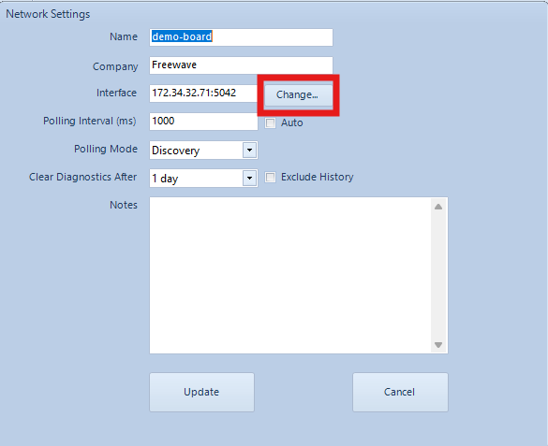
- Click Change… to define IP address and port you will be using to connect to the gateway radio.
  - Note: Tool Suite does not allow for DNS names so you will have to choose an IP address when naming the function in the Zentry Console.
  - Note: The port number will be of the device doing the serial to TCP conversion. The IP address is the IP of the device doing the serial to TCP conversion.
- Click Update
- Tool Suite now has a network that allows Terminal Server monitoring and configuration.

Zentry Setup for TS Remote Serial Radio Connection
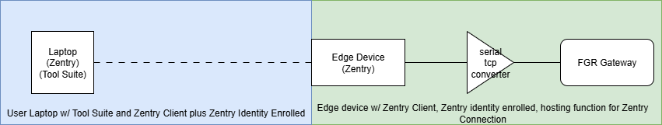
The above wireframe shows the basic setup you will utilize.
- Login https://zentry.freewave.com
- Note: The “Edge Device” should be created in the “Org Devices” section, unless the edge device is an ES1000, in which case it will be claimed under the “ES1000s” section.
  - Hosting a function on a device is the same process whether you are hosting the function on a device in “Org Devices”, “My Devices”, or “ES1000s” sections.
- Select the Edge Device that will be at the gateway radio station.
- Click “Host Function on this Device”.
- Function Name must be an IPv4 type entry.
  - Ex: 192.168.222.210
  - Ex: 10.9.8.7
  - Note: The Function Name is just that, a name, so the IP doesn’t have to be within your networks’ subnet. It is recommended you use a non-public IP range. At least a different subnet than the network your computer will be dialing the function from.
    - Meaning: If your computer is in network: 192.168.20.0/24, then choose any IP outside of that network segment. For example, 192.168.21.10.
- In the Additional Ports section you will enter the port or the serial to TCP conversion device.
- In the Forward Host section you will enter the IP of the serial to TCP device.
- Save the function.
- Click the Name of the function you just created.
- Click “Add Identity to Function”
- Choose the computer you will run Tool Suite.
- Now all the pieces are in place to make this connection.
Making the Connection
- If you used the IP and Port number you entered when setting up the network in Tool Suite, then all you have to do is click the “Start” button in Tool Suite Network Diagnostics view.
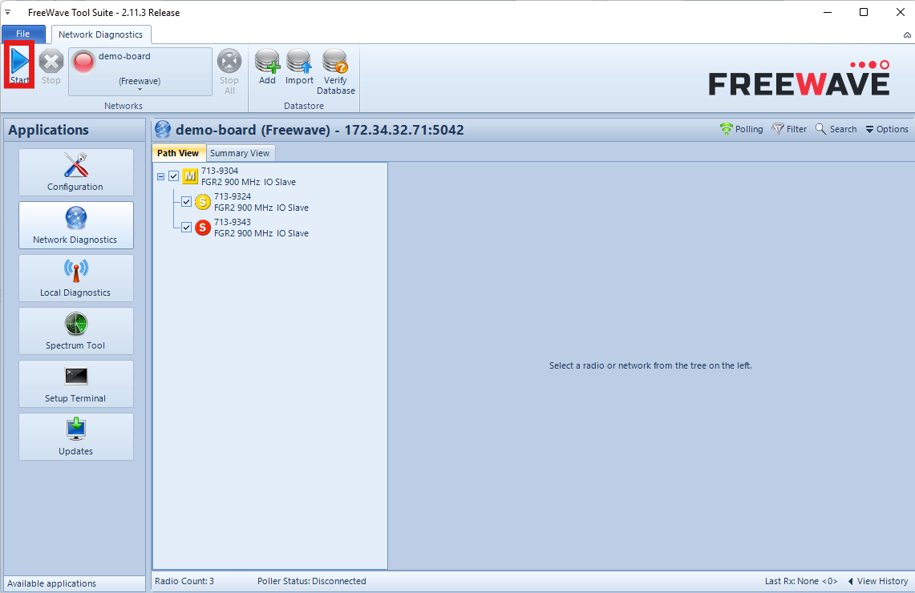
- You can monitor the Poller Status at the bottom of the Tool Suite window.
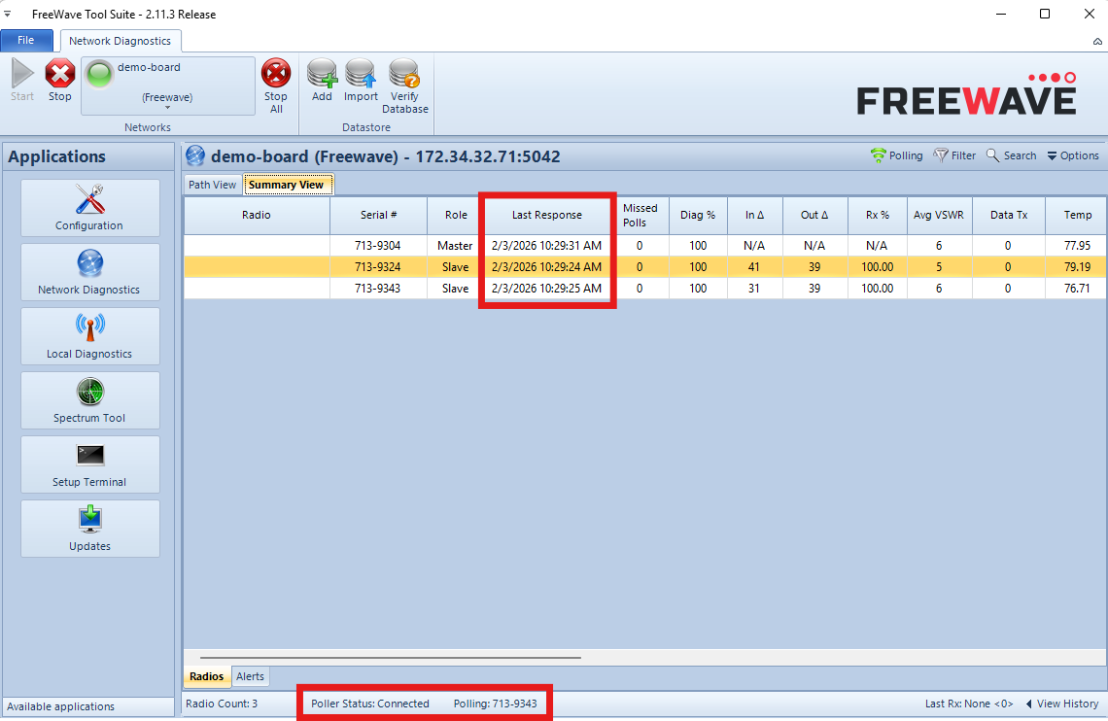
- You should start to see the Last Response increment as well. The Last Response may show increments of two or more seconds. This is normal and is due to latency depending on how the edge device is obtaining network connectivity.

