Purpose: This document is meant to help understand the different parameters, what they are, what they do, and how to utilize them. The first half of this document is an overview of the Zentry console. The latter half will guide you through how to add a device and make a connection via Zentry.

Overview:
Login
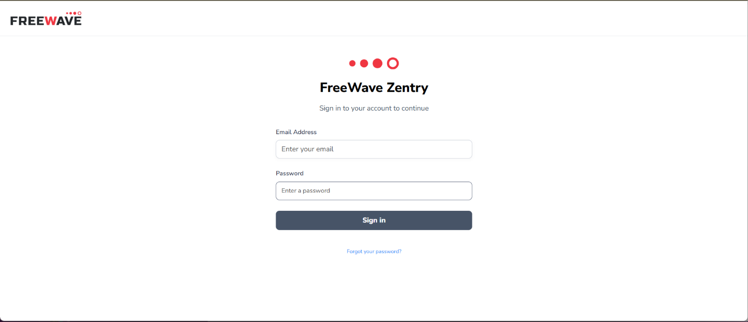
- Zentry Console URL
  - https://zentry.freewave.com/users/log_in

Home Screen/navigation
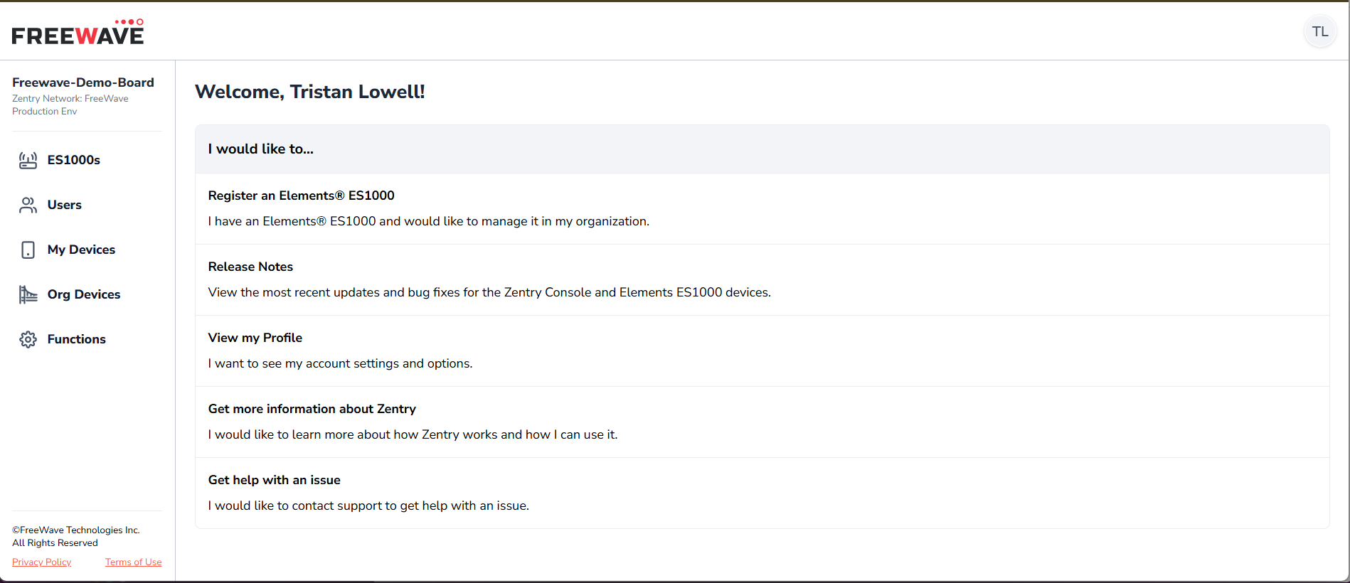
- ES1000s
  - Where you will find claimed ES1000s
  - Where you will claim ES1000s into your organization
  - Where you will perform configuration for ES1000
- Users
  - Where you will invite new users to your organization
  - Where you will edit user profiles
  - Where you will update user permissions
  - Where you will remove users from the organization
- My Devices
  - Where you will add devices that only the logged in user can edit the device
  - Devices created under this tab are not editable to other users in the organization
- Org Devices
  - Where you will add devices that any user in the organization can interact with, granted they have the proper permissions.
- Functions
  - A list of all the functions that have been created in the organization
- User Profile (upper right corner)
  - Where you will edit parameters for the currently logged in user.

ES1000s
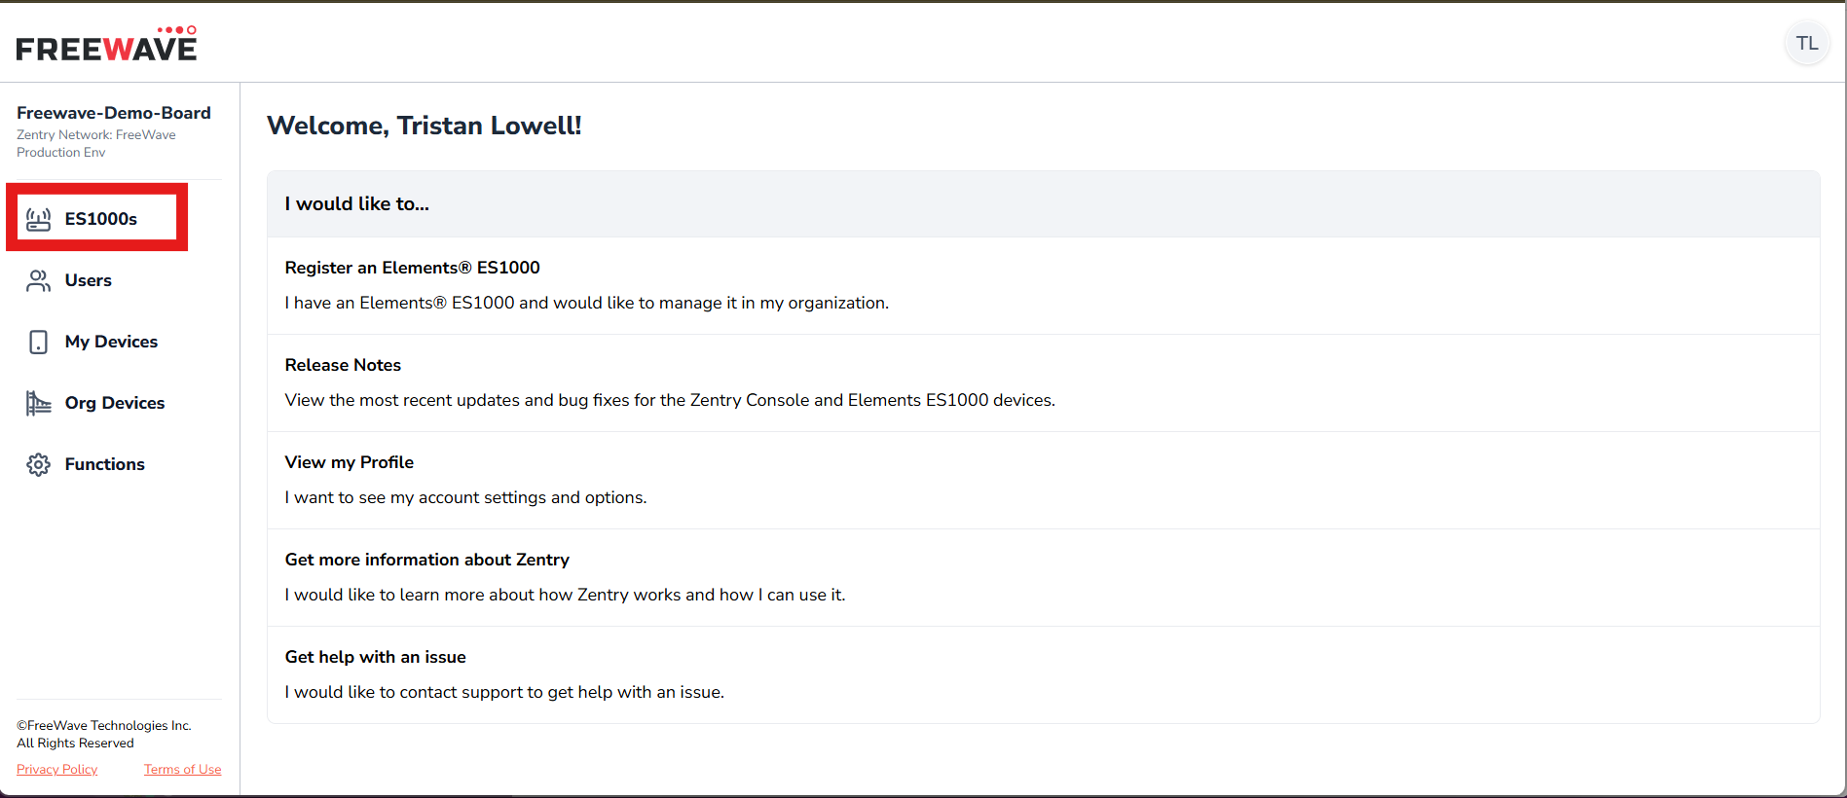
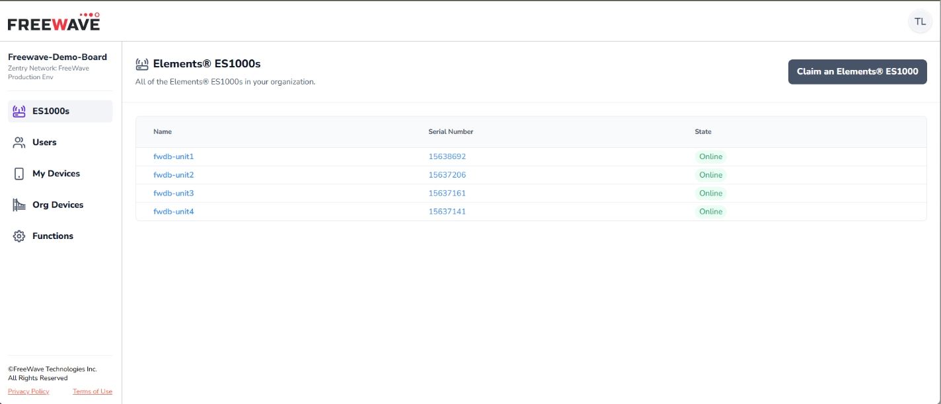
- Table of Claimed ES1000s
  - Name Column
    - The name you gave the ES1000 during the claiming process
    - Clickable and brings you to the main page of the specified ES1000
  - Serial Number Column
    - Serial Number of the claimed ES1000
    - Clickable and brings you to the main page of the specified ES1000
  - Status Column
    - Indicator providing status of the ES1000 connection to MQTT Broker for Telemetry of the ES1000
- Claim Elements ES1000
Claiming an Elements ES1000
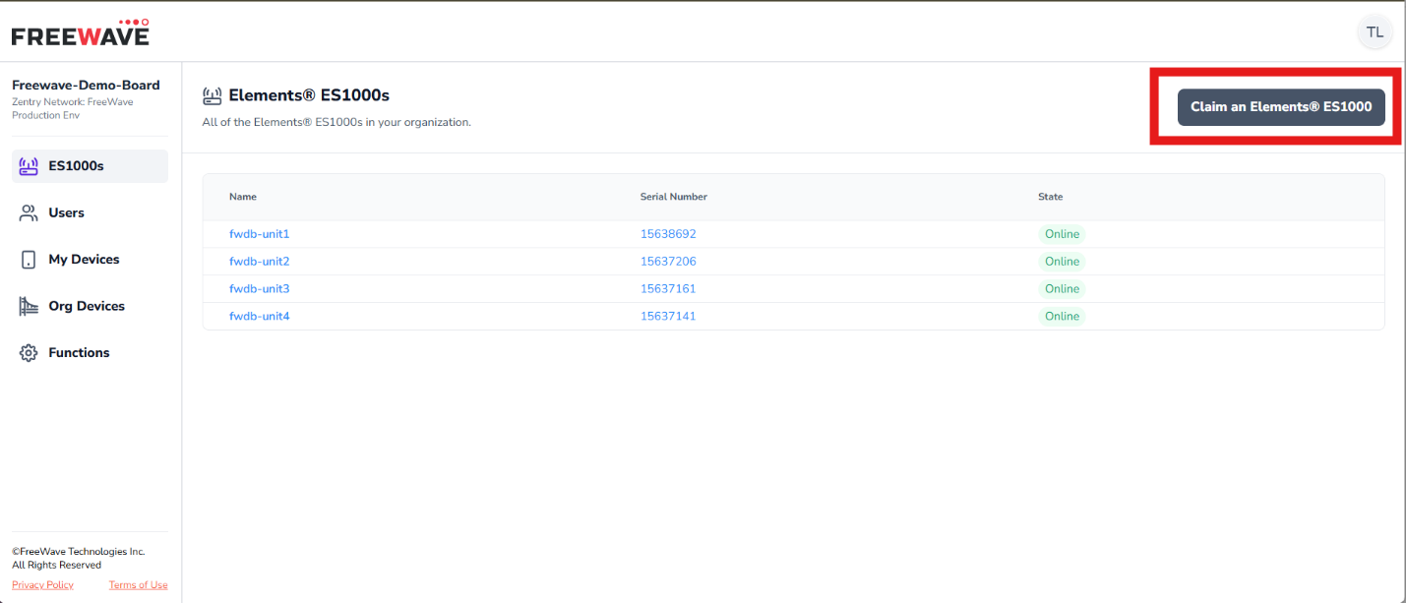
- Enter the Claim Token in the Specified Box
  - The claim number is located on a sticker on the ES1000 hardware unit.
  - Insert photo
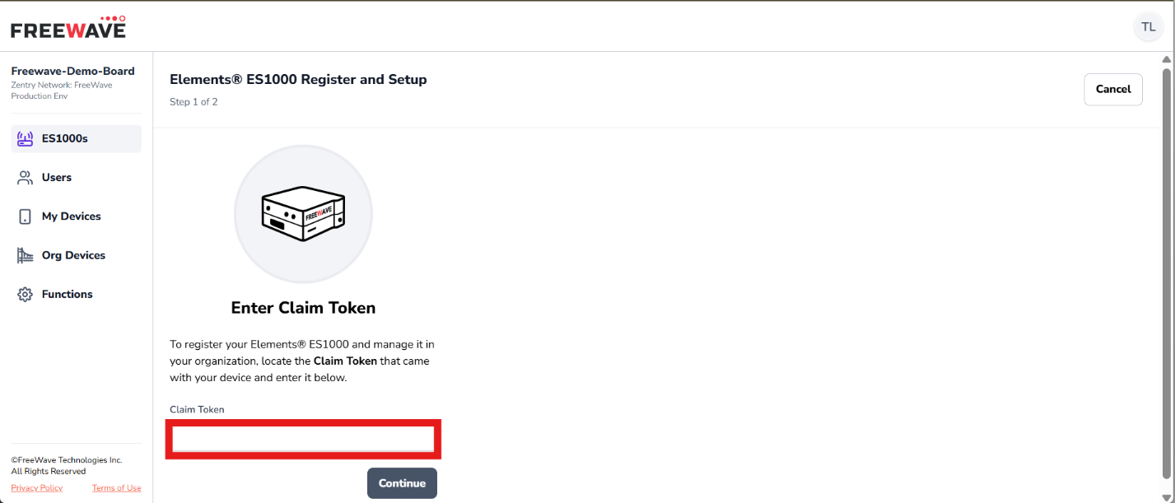
- Next Enter a Name for the ES1000
  - If no name is given the serial number of the unit will be used.
- You can now click the ES1000s tab on the left-hand navigation section and see your claimed ES1000 on the table.

Main ES1000 Specific Page
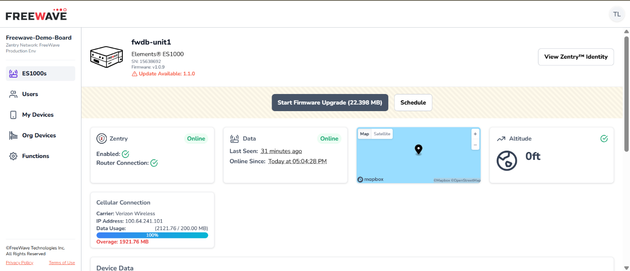
- Firmware Update Section
  - Start Firmware Upgrade
    - Initiates the new firmware update ready for deployment for the ES1000.
  - Schedule
    - You can define a specific time when you want the available firmware update to initiate.
- Zentry Tile
  - Enabled
    - Indicates if the device is connected to the Zentry network
  - Router Connection
    - Indicates if the device has a connection to a Zentry router used in moving traffic across the Zentry network.
- Data Tile
  - Last Seen
    - Time elapsed since last broker check-in
    - The ES1000 telemetry check happens every hour
  - Online Since
    - Last UTC timestamp ES1000 checked in with Broker.
- Map Tile
  - If ES1000 has a proper GNSS antenna with proper line of site the proper map location with the associated coordinates will populate
  - If no antenna and/or no proper line of site, then you will see the map as shown above.
- Altitude Tile
  - In conjunction with the Map Tile, if the ES1000 has sufficient configuration the GNSS data will populate the “Altitude” data in the respective tile.
- Cellular Connection Tile
  - Carrier
    - Shows the current cellular carrier the SIM in the ES1000 is connected.
  - IP Address
    - IP address leased to the ES1000 SIM by the current carrier
  - Data Usage
    - Amount of data that has been passed through the cell interface on the ES1000 and thus the amount of data used by the data plan associated with the SIM.
- View Zentry Identity
  - Where you will configure the functions the ES1000 will host and the identities that can access functions hosted on the ES1000.
View Zentry Identity
- Edit Device Name
  - Allows you to update the name given to the ES1000
- View Device Dashboard
  - Brings you back to the main dashboard for the ES1000 currently being viewed.
ES1000 Remote UI Access Management
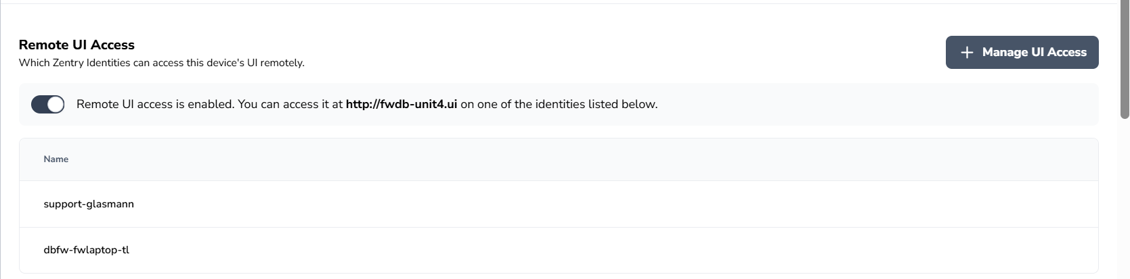
- Enable/Disable Toggle
  - Enables the use of the console generated DNS record for the claimed ES1000

- Identity Access Table
  - Name Column
    - Shows the identities within your organization that have access to the ES1000 Web GUI.
- + Manage UI Access
  - This is where you grant identities access to the ES1000 Web GUI.
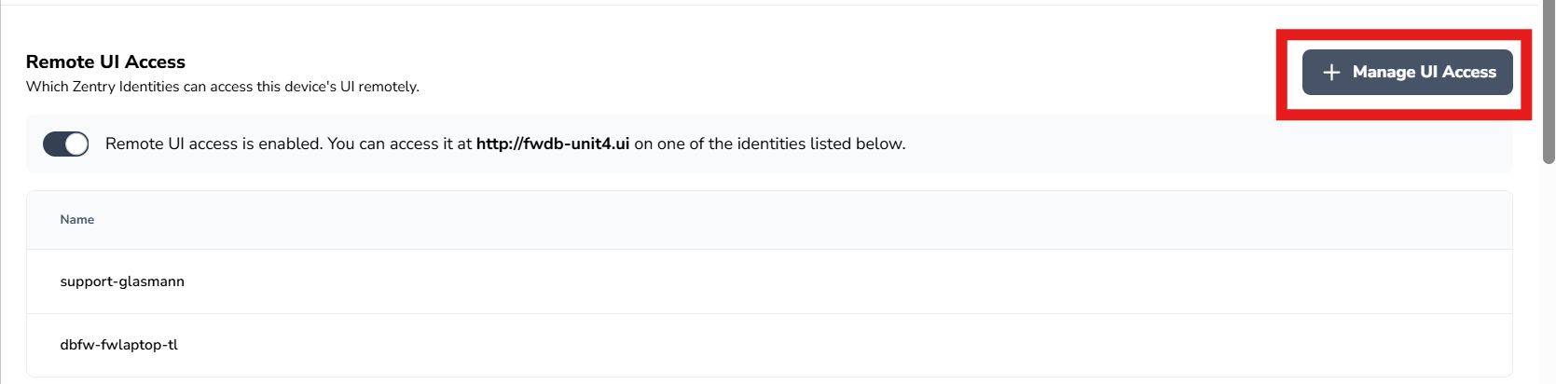
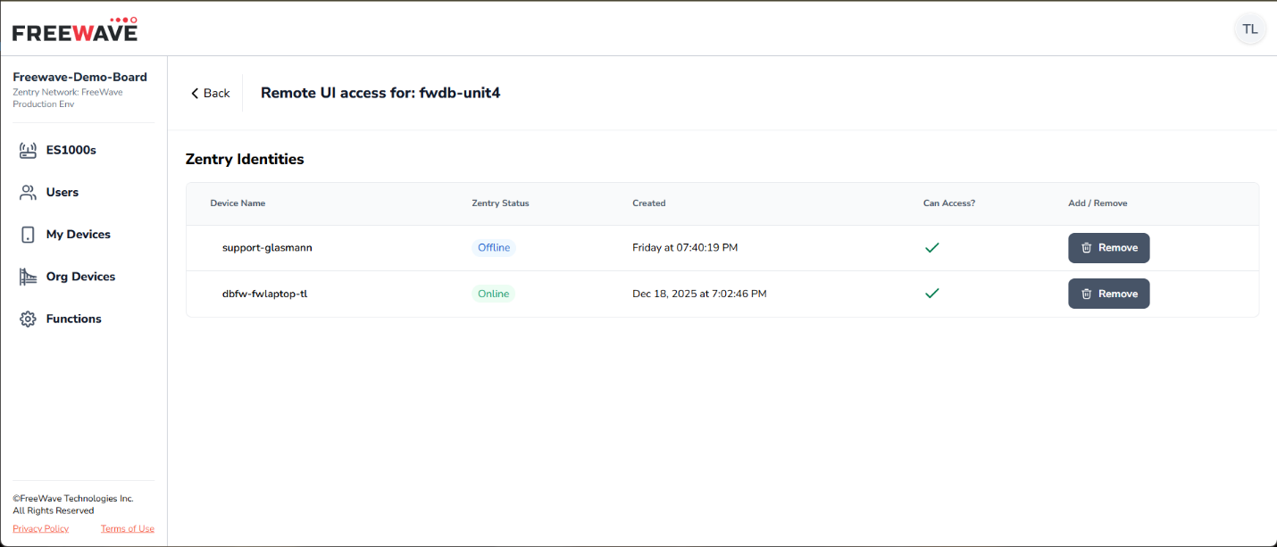
- List of devices (identities) that a user can add to the policy, granting access to ES1000 Web GUI.
- Add/Remove
  - A device that has been granted access shows a green checkmark under the “Can Access?” column.
    - The button under the “Add/Remove” column will show “Remove” as the option.
  - A device that has NOT been granted access to the ES1000 Web GUI will show a red “X” under the “Can Access?” column.
    - The button under the “Add/Remove” column will show “Add” as the option
ES1000 Hosted Functions
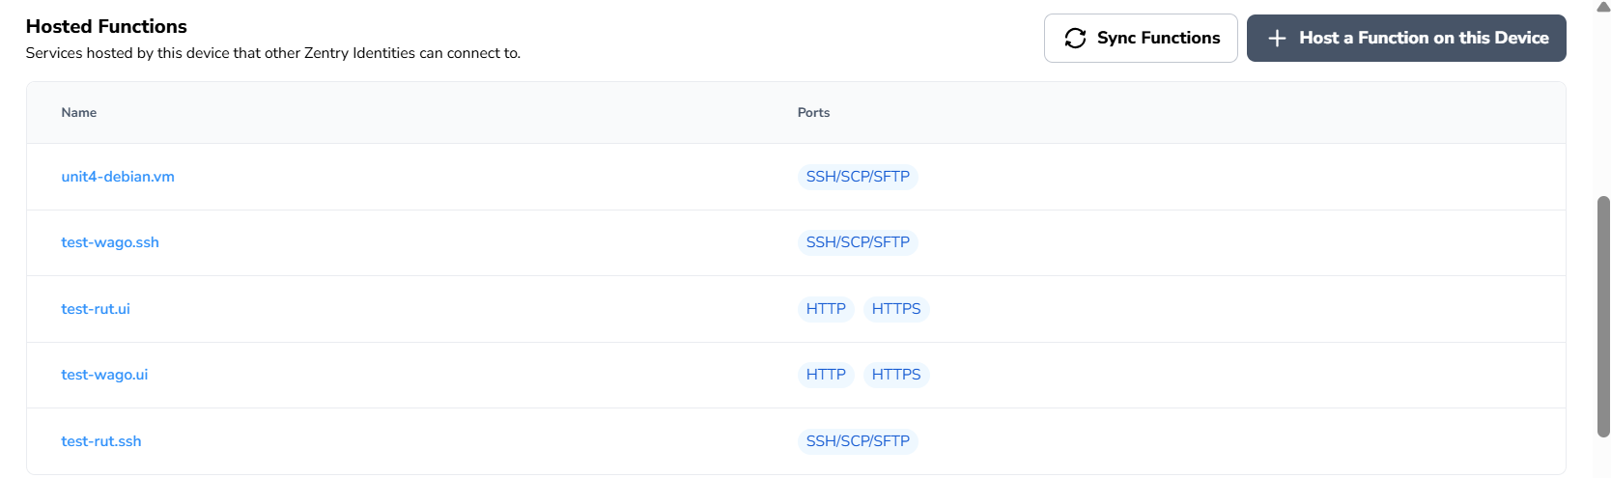
- Hosted Functions Table
  - Name Column
    - Name (DNS record or IP address) given to the function
  - Ports Column
    - The ports specified that the function will grant access.
  - Sync Functions
    - Invoking this will send a signal to the ES1000 to re-sync the functions the identity is hosting or has access.
  - + Host a Function on this Device
Functions ES1000 is Granted Access
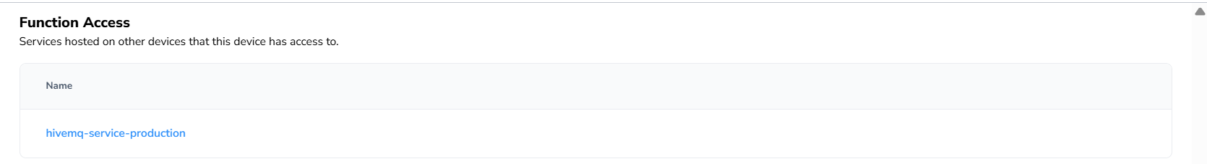
- Function Access Table
  - Name Column
    - Name of function this device can access
ES1000 Identity Info Table
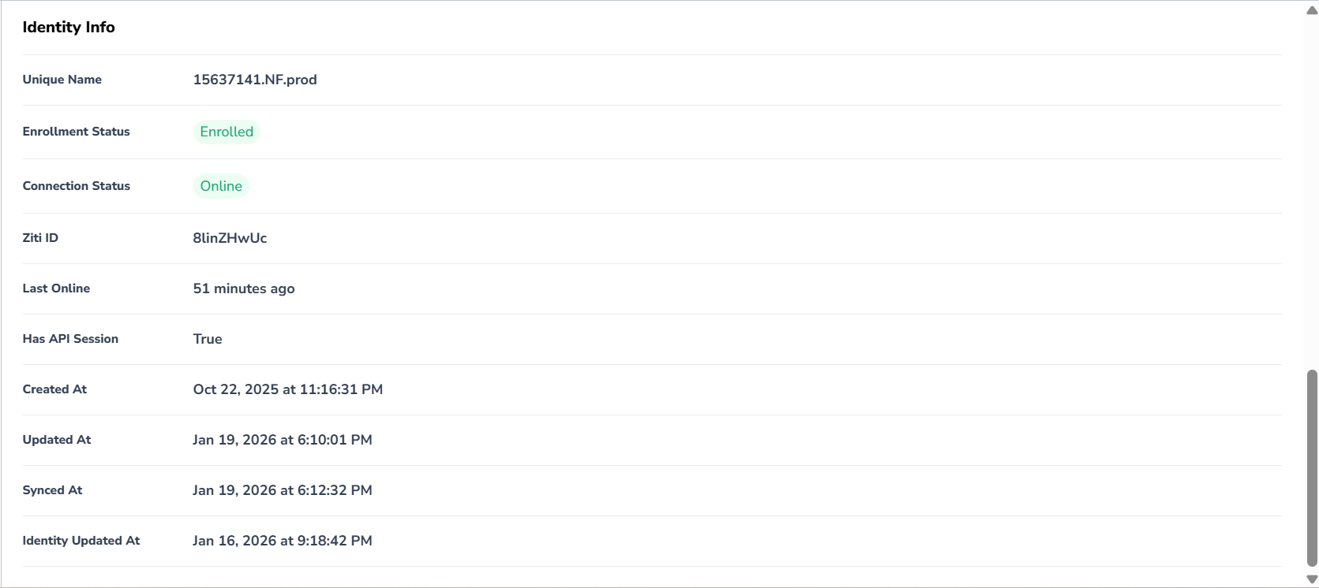
- Unique Name
  - Name given to the identity that allows the device connection to the Zentry network.
- Enrollment Status
  - Indicates if the identity has been enrolled or if enrollment is pending.
- Connection Status
  - Indicates the device (identity) is currently connected to the Zentry network and is reachable via Zentry.
- Ziti ID
  - Unique string for identity
- Last Online
  - Time elapsed since last check-in by device (identity)
- Has API Session
  - Indicates the device (identity) has an active API session necessary for connection and communication in the Zentry network.
- Created At
  - Date the identity was created
- Updated At
  - Date the last saved edit was for the identity.
- Synced At
  - Date of the last time the device (identity) did a sync operation to ensure the hosted functions and function access are up to date.
- Identity Updated At
  - Date any edits to the identity were saved.
Users
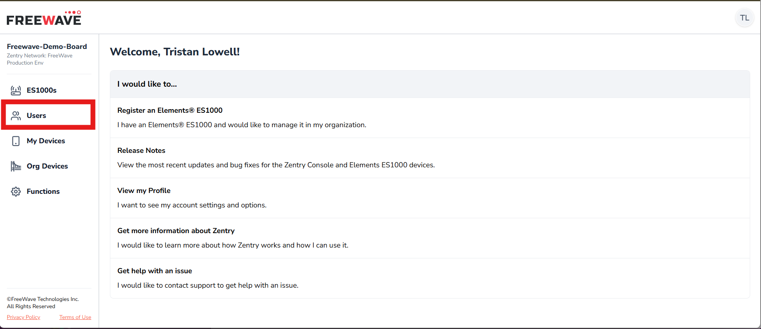
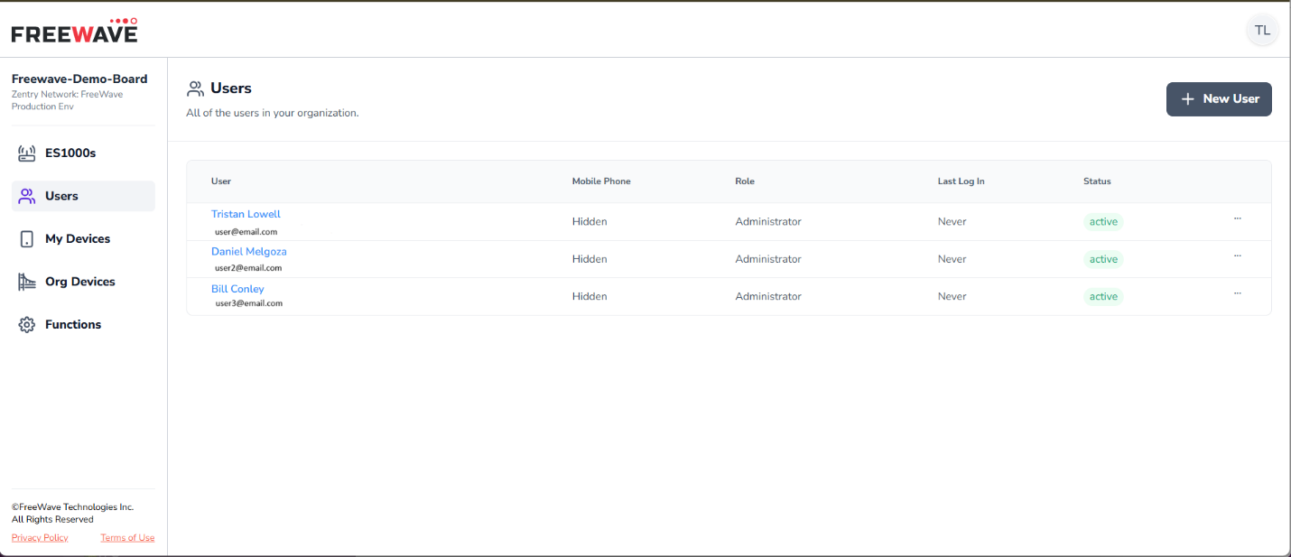
- User Column
  - Name of User
  - Email of User
- Mobile Phone Column
  - User phone number
- Role Column
  - Shows user role
- Last Log In Column
  - Timestamp of last time user logged in
- Status Column
  - Shows status of user
- Edit User ellipses
  - View user profile
  - Update user permissions
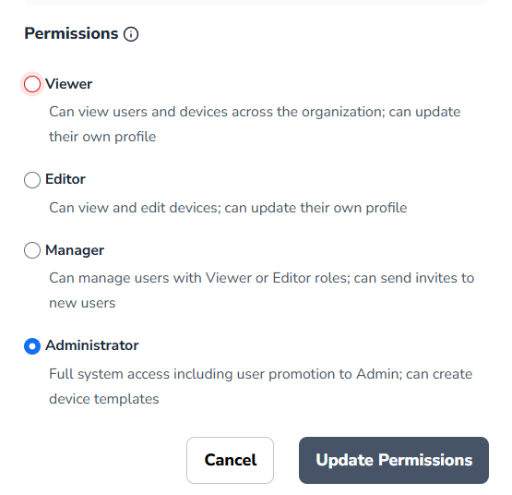
- New User
  - Invite new user to this organization

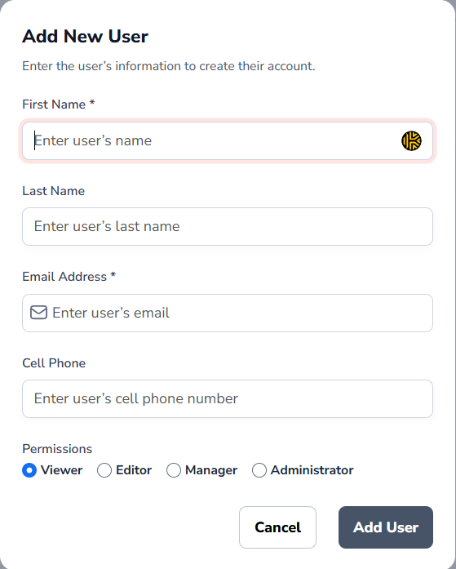

My Devices
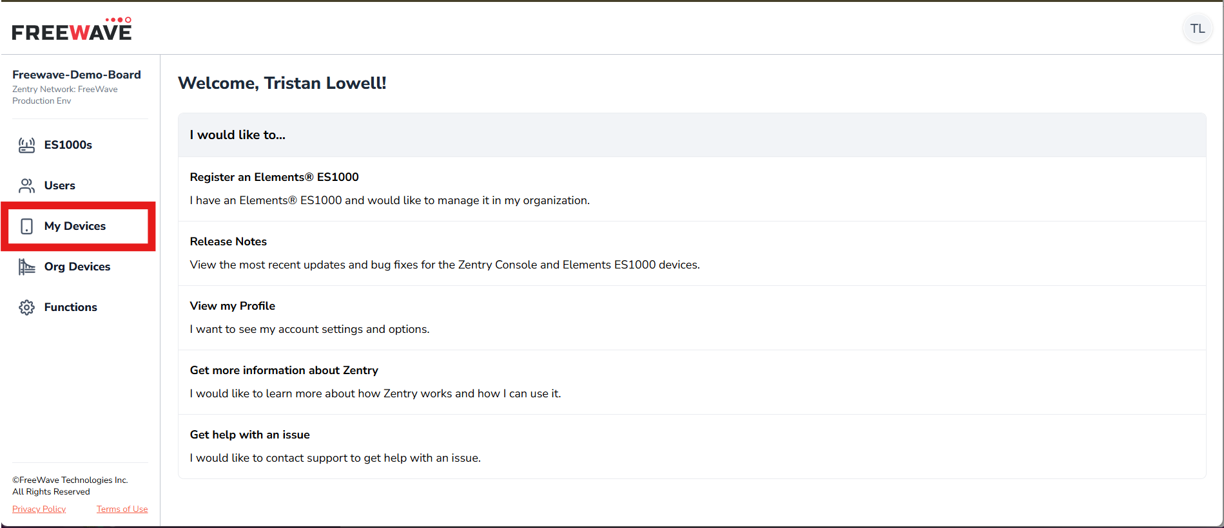
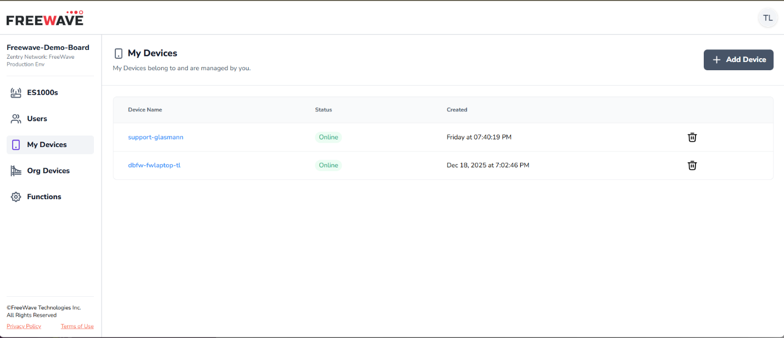
- Device Table
  - Device Name Column
    - Name given to the identity for the device
  - Status Column
    - Shows if the devices’ Zentry client, and the associated identity, is online
  - Created Column
    - Date the identity was created
  - Delete Identity Icon
    - Delete the identity
    - This will remove the device from the Zentry Network you created.
    - This will remove any access to Functions
    - This will remove and functions this device was hosting
    - You CAN NOT recover a deleted Identity.
- + Add Device
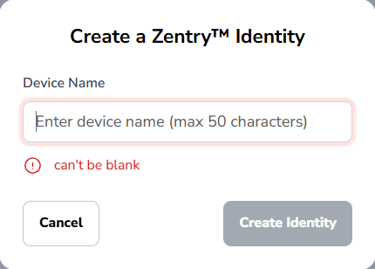

Org Devices
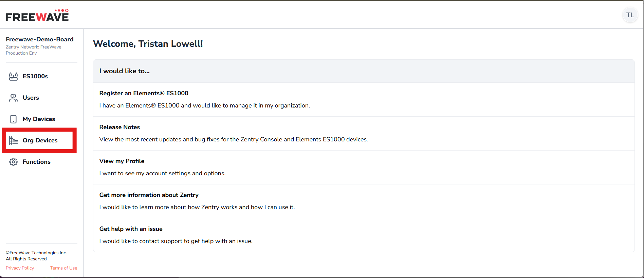
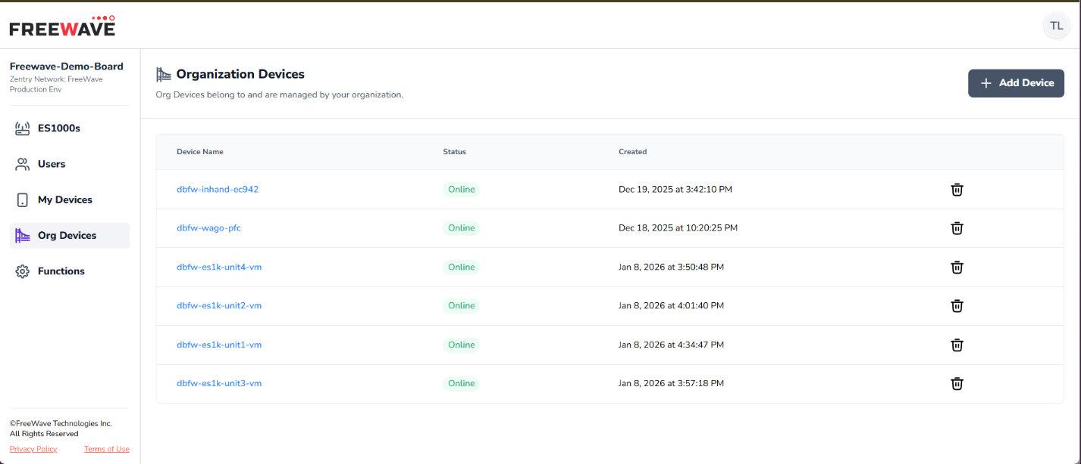
- Organization Device Table
  - Device Name Column
    - Name given to the device (identity) created.
  - Device Status Column
    - Indicates whether the device is connected to Zentry Fabric or not.
  - Device Create Column
    - Date when device was created
  - Delete Device Icon
    - Delete the identity
    - This will remove the device from the Zentry Network you created.
    - This will remove any access to Functions
    - This will remove and functions this device was hosting
    - You CAN NOT recover a deleted Identity.
- + Add Device

Functions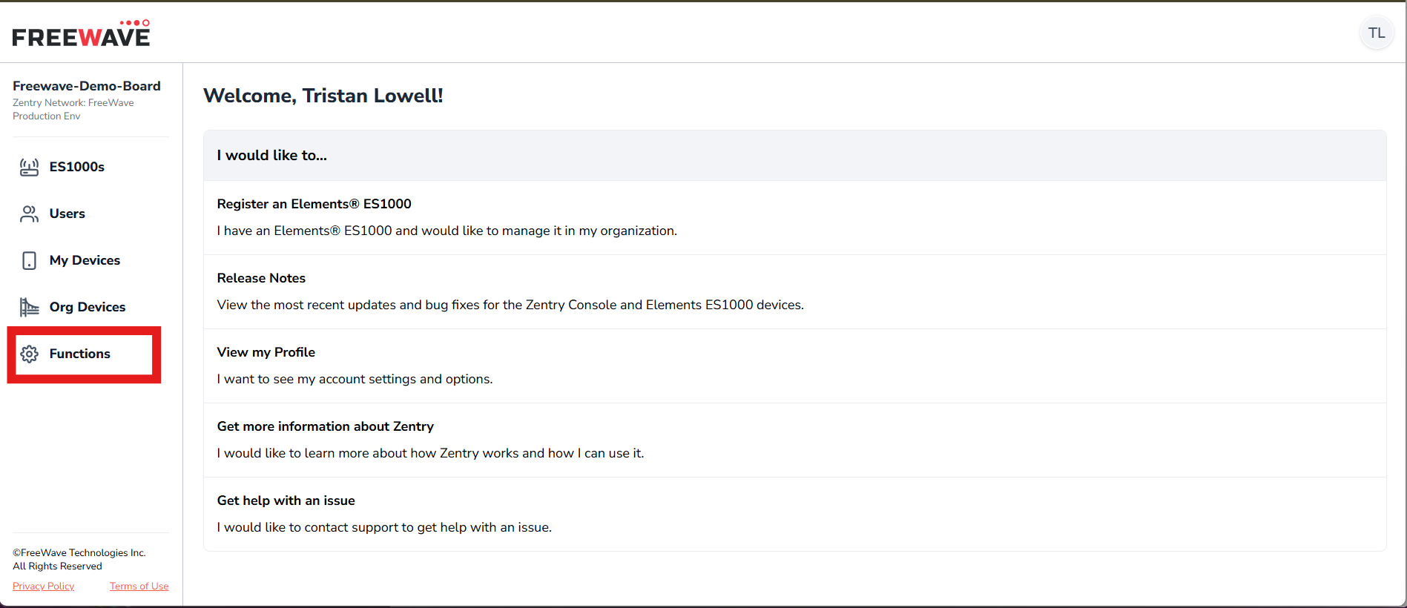
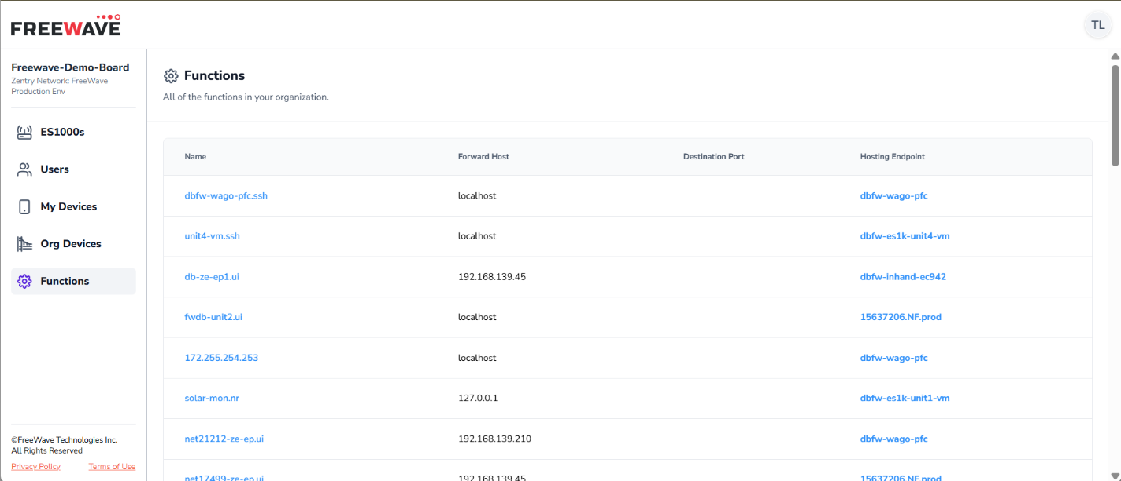
- Functions Table
  - Name Column
    - Function name
      - This is the name a user (device) will use to reach the desired destination service (i.e. HTTPS, SSH, RDP, etc.)
  - Forward Host Column
    - Destination user (device) will reach when dialing the function
    - Example:
      - If you type in a function name of http://my-edge-device.ui into a web browser address bar
      - With forward host IP of 192.168.122.14
      - The user (device) will end up at the IP entered in the “Forward Host” section when creating the function.
  - Destination Port Column
    - Port defined in the function
  - Hosting Endpoint
    - Device that is hosting the function.
Add Device and Grant Access to a Function
- There are two places to Add a device.
  - My Devices
    - These are devices that are only editable by the user that created the device.
  - Org Devices
    - These are devices that are editable by any user in the organization that has the proper permissions
- The recommended procedure is, if the device you are adding is a personal device like a laptop, phone, or tablet, this would most often be created under the My Devices tab. If the device is meant to be accessible by many other devices (identities) then this would most often be created under the Org Devices tab.
  - However, if a laptop is being used as a server for a network, for example allowing remote desktop access to control remote devices that many other users will interact with, then you add the device under the Org Devices section. This way anyone in the organization with proper permissions can add their device (identity) to be granted access to the functions hosted on the “Org Device”.
- The procedure for adding a device to Org Devices is the same as adding a device to the My Devices tab.
Add Device (My Devices)
Note: for this walkthrough we will assume we are adding a personal laptop a user will utilize to reach functions hosted on other devices.
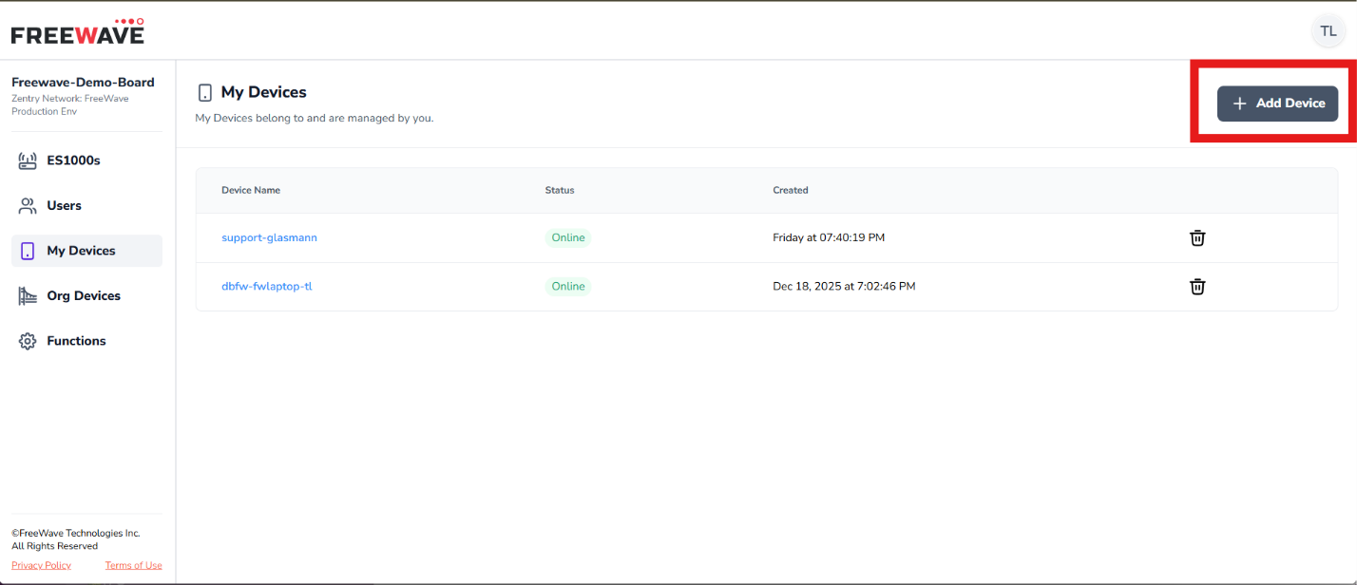
- Click the + Add Device button in the upper-right corner when viewing the “My Devices” tab.
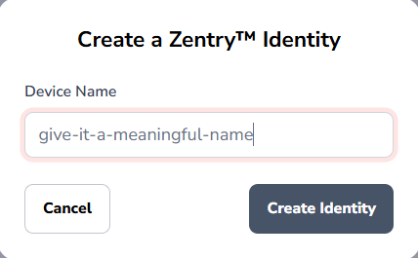
- Provide a meaningful name for the device so you establish clear identifiers for keeping track the devices created for you Zentry network.
- Click Create Identity
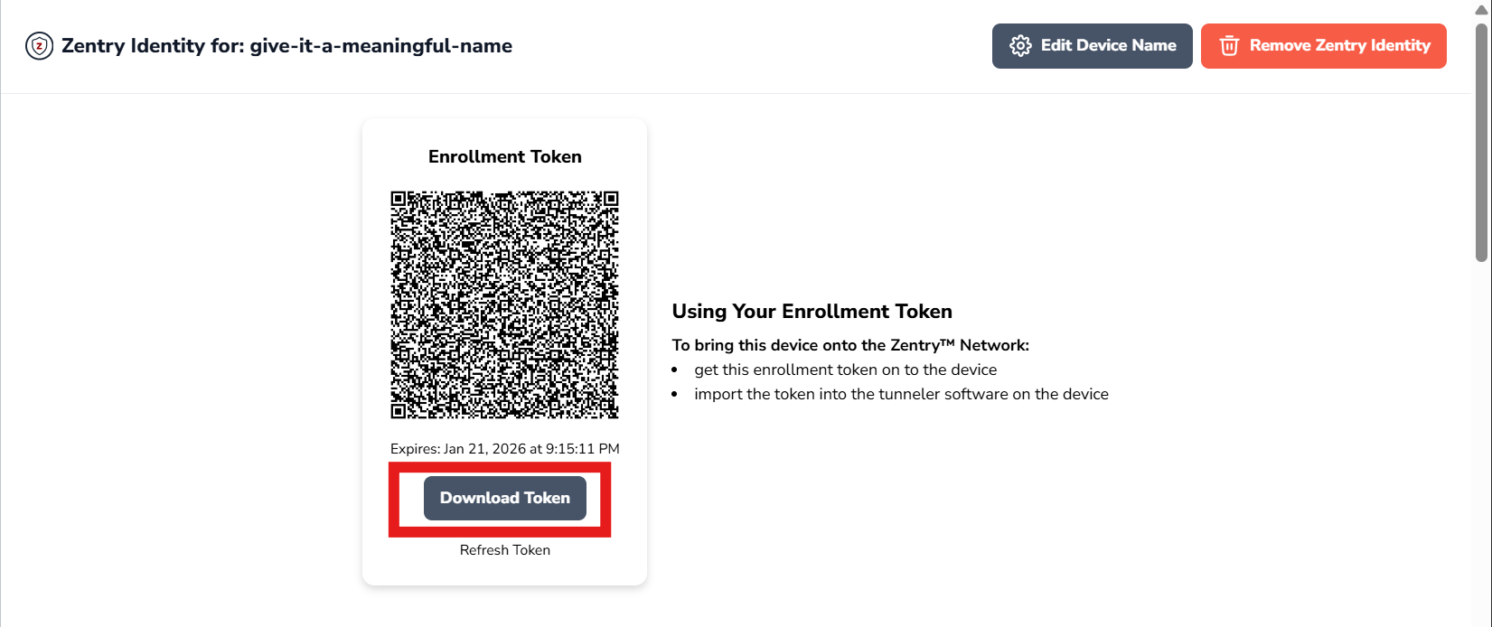
- After clicking “Create Identity” you will be brought to the page where you can download the enrollment token you add to you Zentry client on your laptop.
  - Please see separate guide for installing the Zentry client onto your device.
  - If you are creating this identity for a smartphone or tablet you can use the QR code to pull the enrollment taken right to the mobile device.
- Click Download Token
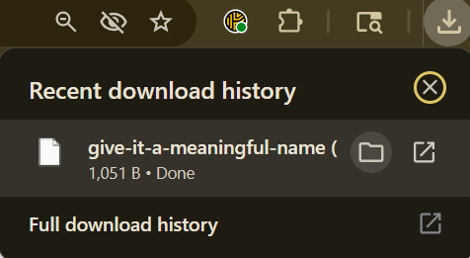
- The token usually goes to the “Downloads” folder on your computer.
  - You can click the “folder” icon and that will open your file system on your laptop of where the token was downloaded.
- Now you will add the token to the Zentry client
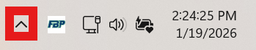
- In the bottom-right corner of most windows laptops you have a carrot symbol which when clicked will display applications running in the background
  - On Mac these background processes are usually in the top most bar of your desktop window
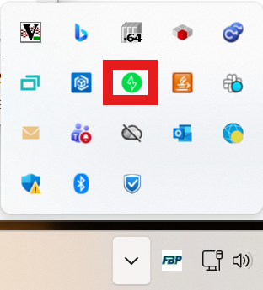
- The red square shows the Zentry client icon (green indicating “on”, red indicating “off”).
  - Click this icon to bring up the Zentry client GUI
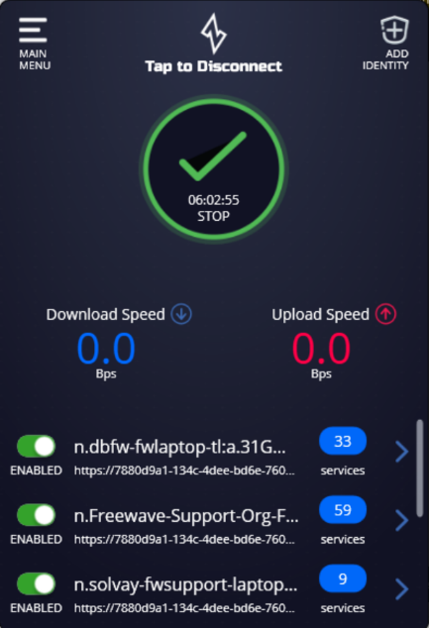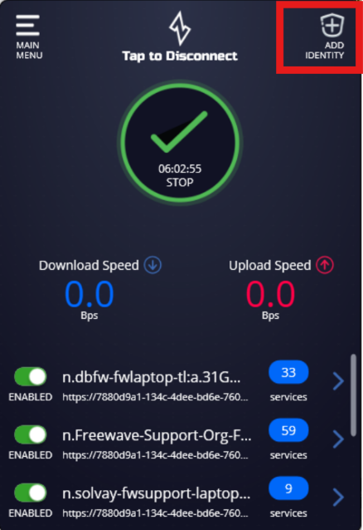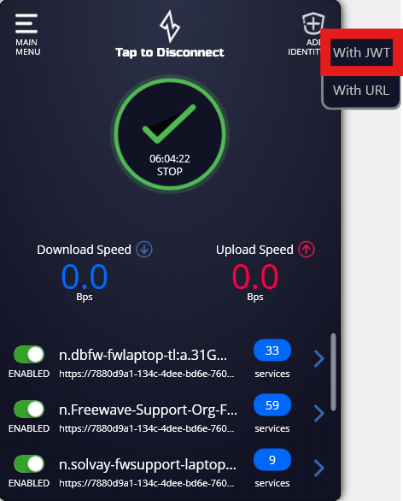
- In the upper-right corner of the client GUI you will see “Add Identity”
- Click “Add Identity” to choose “With JWT”
- This will open the file system of your laptop
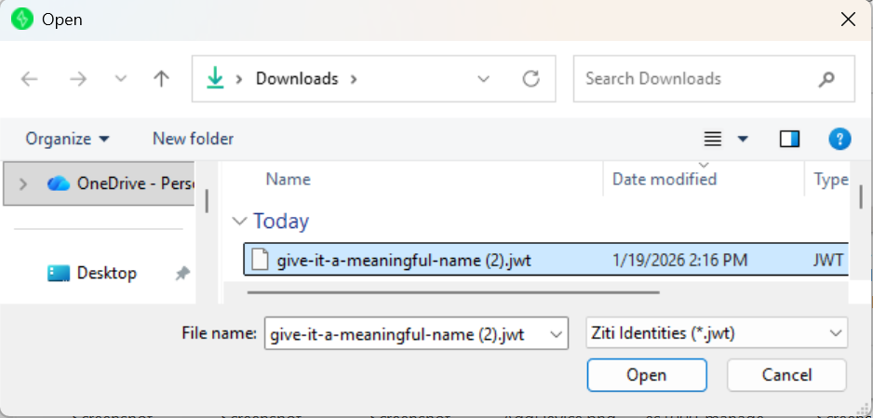
- Choose the file (double-click or select and click “open”) with the name you defined when you created the Identity in the Zentry Console.
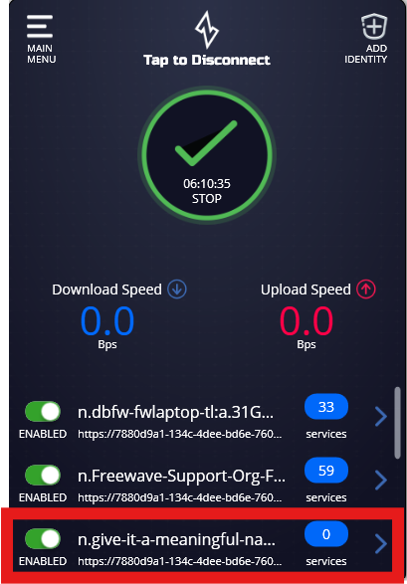
- After successful enrollment you will see the name of the identity in the list of identities on the Zentry client GUI.
  - Notice the Identity highlighted has a zero-value shown for the “services” (these are called functions in the Zentry console).
  - This is due to this identity having no access to functions hosted by other devices (identities) OR is not hosting any functions itself.
- Your laptop is now successfully enrolled into the Zentry network associated with the organization where you created the identity.
  - Before your laptop can communicate over the Zentry network there must be at least one other device with an enrolled identity that is hosting a function which your laptop has been granted permission to access.
- In the Zentry console, if you refresh the page where you downloaded the enrollment token you will see that the UI has changed.
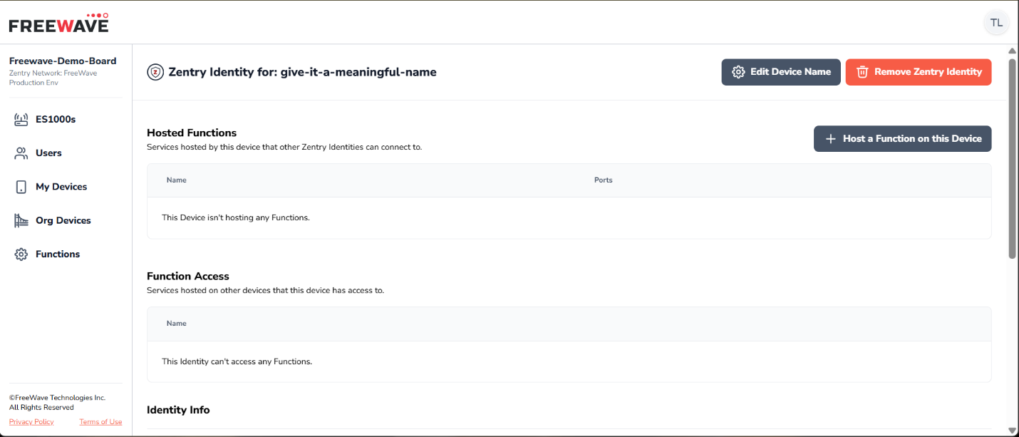
- The “Download Token” option is gone and you now see:
  - Hosted Functions
    - Functions this device is hosting
      - You would give a device access to one of the functions in this table
  - Function Access
    - Function this device has been granted permission to access.
      - This is a list of functions (hosted on other devices) that you gave this device permission to access.
  - Identity Info
    - Now shows the updated information related to the creation, enrollment, and status of the identity.
Grant Identity Access to Function
- To grant another device (like a laptop) access to a function being hosted on another device we need to navigate to the device hosting the function we want to access.
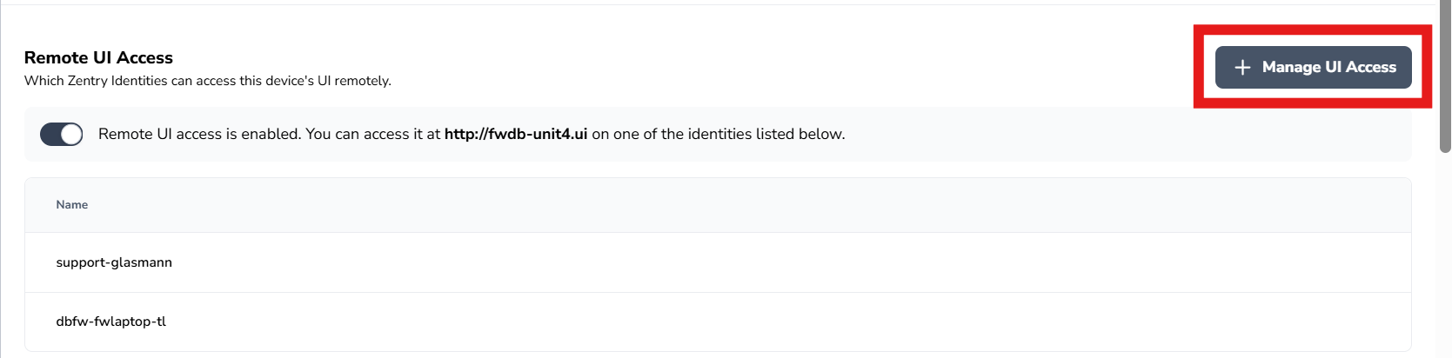
- Click the “+ Manage UI Access”
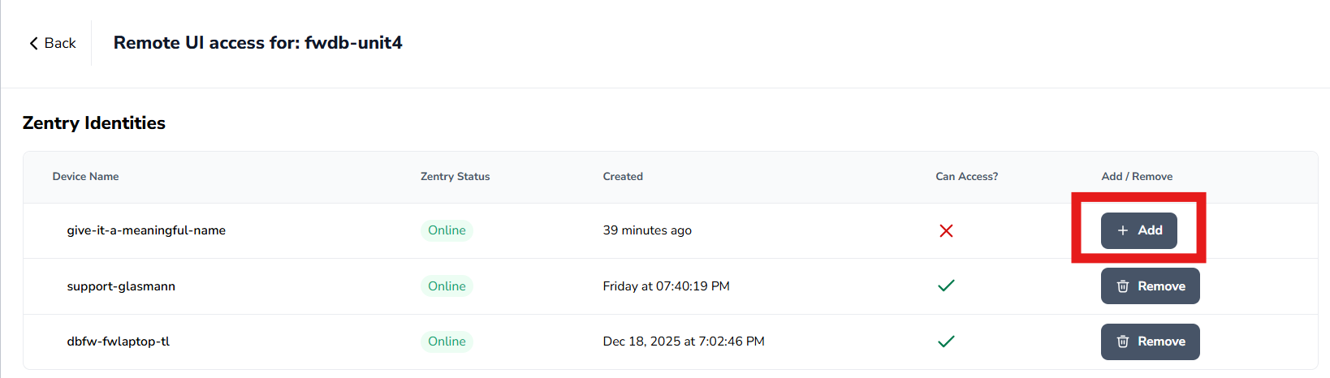
- Click the “+ Add” button next to the desired identity.
- Now the device “give-it-a-meaningful-name” has access to the Web GUI of the ES1000 named “fwdb-unit4”.
- Click the “Back” button after adding the device to find the URL you use to reach the Web GUI your device (identity) has been granted permission to access.
  - You can confirm access by checking the Zentry client on your device.
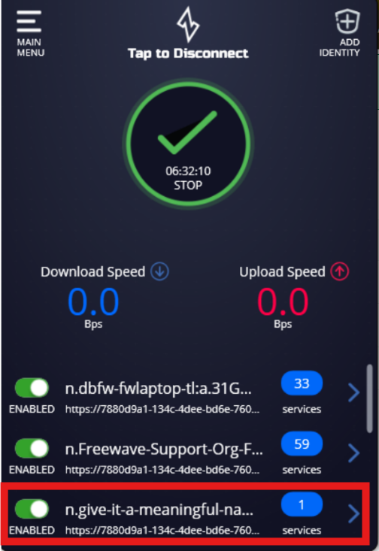
  - The newly enrolled identity now has been granted access to a single function. In this case accessing a Web GUI on port 80.
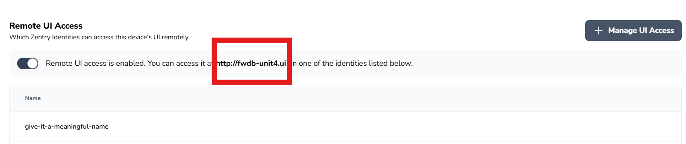
- You can now see under the “Remote UI Access” for this ES1000, the device (identity) has been granted permission to access the Web GUI of an ES1000.
- Copy the URL http://<Name-Given-to-ES1000>.ui
  - In this case it is http://fwdb-unit4.ui
- Paste the URL into the address bar of a web browser
- Press Enter to dial the service hosted on the device.
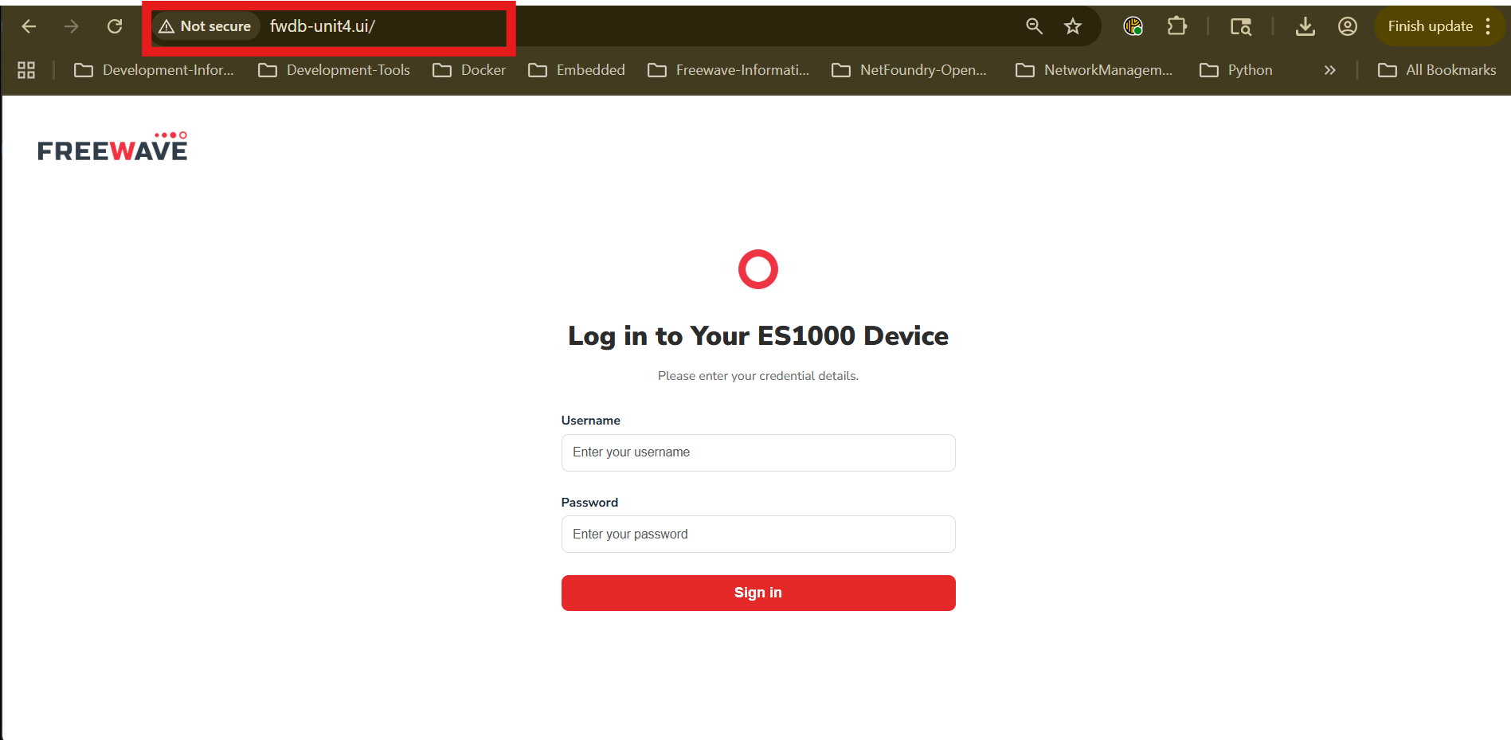
- You have successfully dialed a service hosted on another device.
Host a Function and Grant Access
- To host a function, first create or choose an existing device (identity).
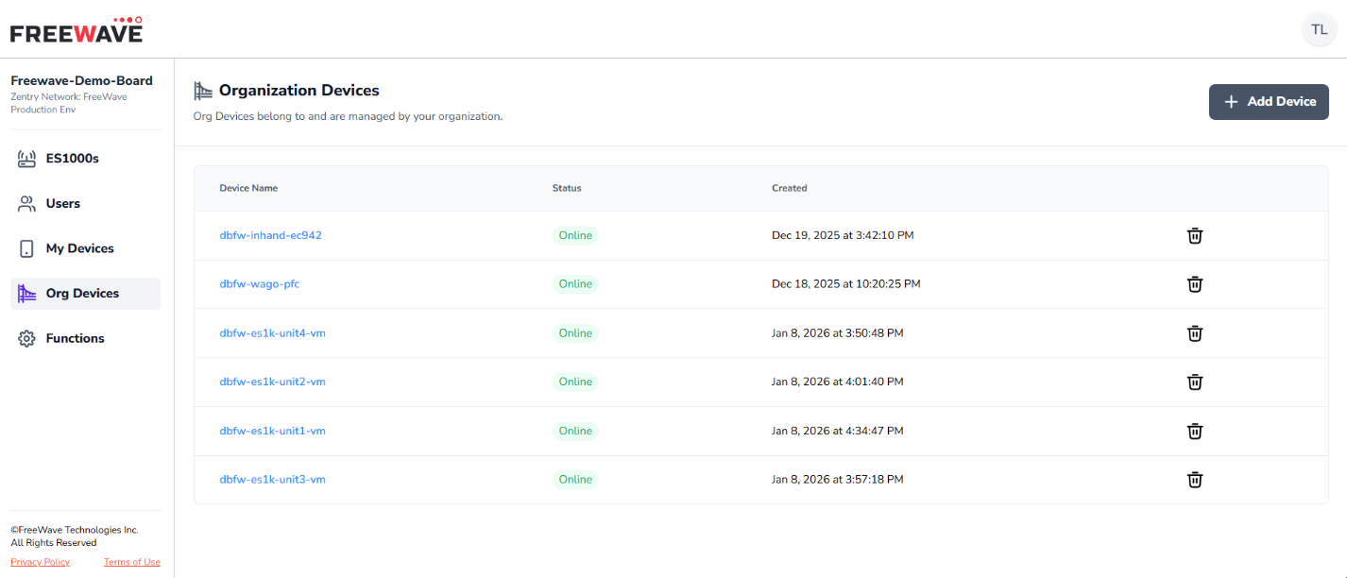
- Click on the device name in the table showing your devices (can be a device under the “My Devices”, “Org Devices”, or “ES1000s”)
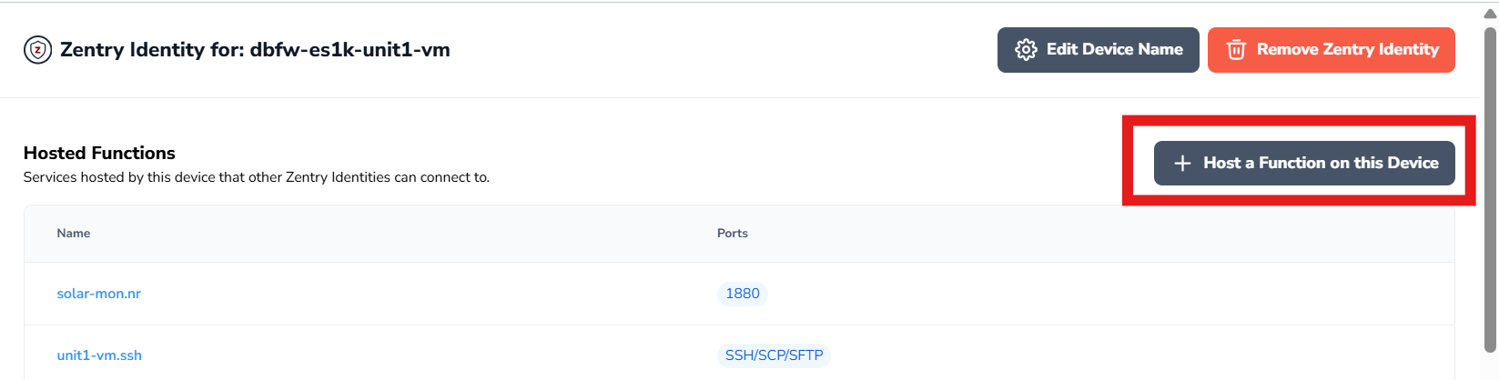
- Click the + Host a Function on this Device.
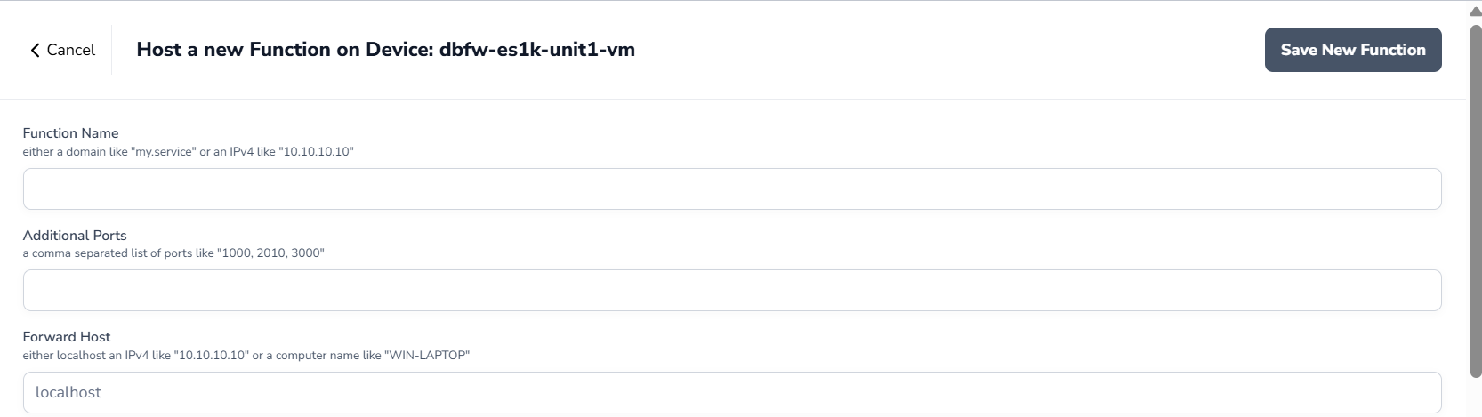
- Function Name
  - This is a DNS record or IP Address used to dial the function from another device.
  - Example DNS record: rpi-site5.ssh
    - This is the string you would use to reach the device via SSH
- Additional Ports
  - Comma separated list of ports not found in the “Well Known Ports” section below.
- Forward Host
  - The destination of the function.
  - If the function is hosted on a device AND the service you are trying to reach is hosted on the device, a Web GUI for example, then you will enter “localhost” or “127.0.0.1” as the Forward Host entry.
    - If you use “localhost” IPv6 will be utilized by the client for resolving the Zentry traffic.
    - If you use “127.0.0.1 then only IPv4 will be utilized by the client for resolving Zentry traffic.
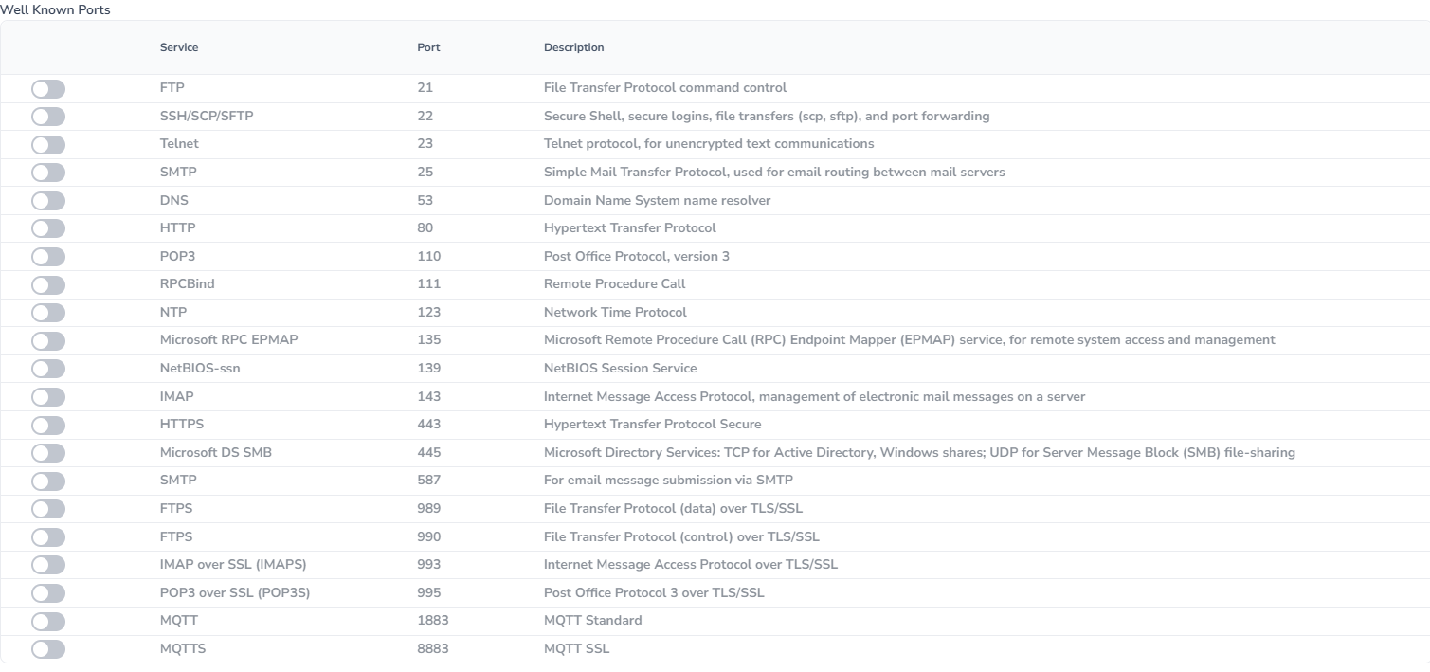
- Below the entry fields for the function being created, there are a list of “Well Known Ports” that you can use the toggle switch on the left side of the table to add those ports to the function.
- In the upper-right corner save the function
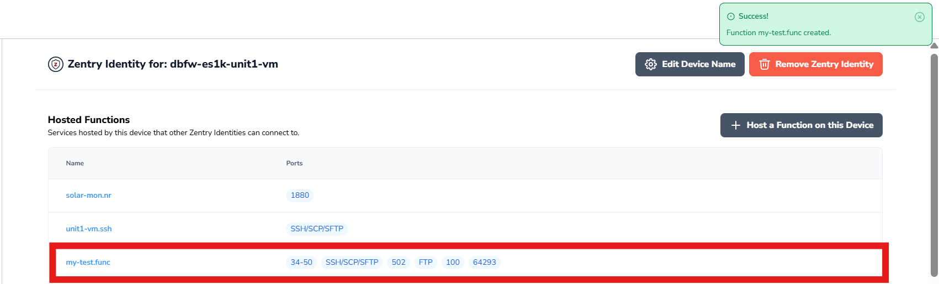
- Click on the name of the function you want to grant another device permission to access.
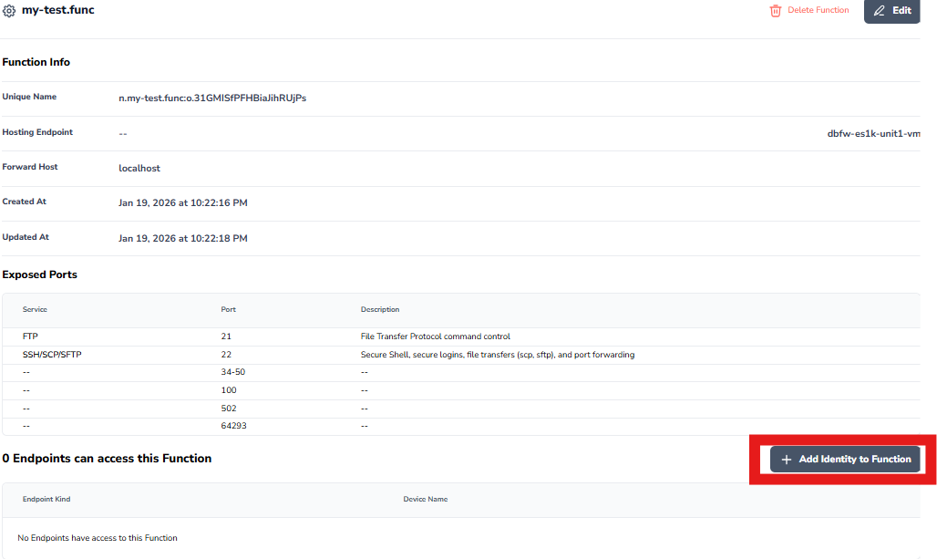
- Click on + Add Identity to Function
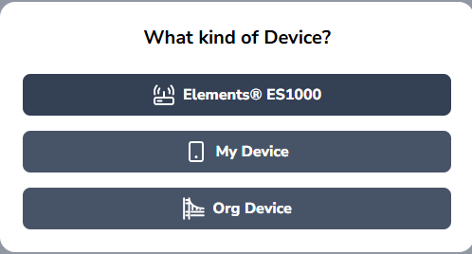
- Choose the group of devices where the device you are providing access to this function resides.
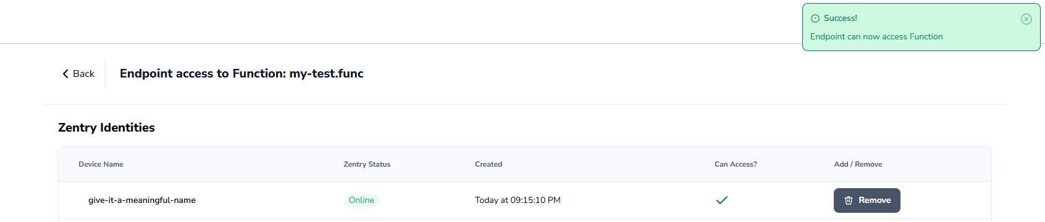
- Click the Add button to grant access to the function.
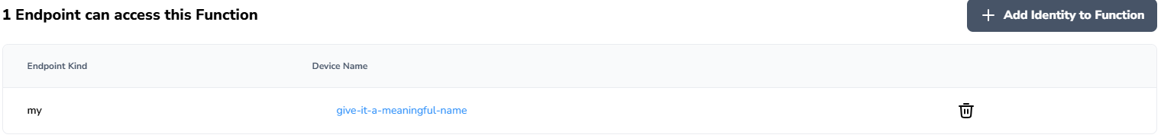
- Now you can use the function name to allow the dialing device (one you just granted permission to access the function) to connect to the hosting device (device hosting the function) to reach the service (function) you have defined.

