Using an ES1000 for SMT Remote VNC Connection
- Procedure for Use-Case
  - Claim ES1000
  - Host a function on ES1000
  - Create identity
  - Enroll new identity onto user laptop
  - Grant laptop permission to access Hosted Function on ES1000
  - Open VNC software application
  - Enter the Function name into the VNC application
  - Initiate VNC session.
- What is Needed
  - Laptop w/ Admin level permissions
  - ES1000 claimed and installed in the network where the SMT machine resides.
  - Identity for laptop
  - VNC software
  - Stable internet connection
- VNC
  - TightVNC was used in this example.
    - Other VNC applications have not been tested.
The purpose of this guide is to guide you through the steps needed to create a remote VNC connection to a manufacturing line using the ES1000 and Zentry.
- Log into: https://zentry.freewave.com/users/log_in
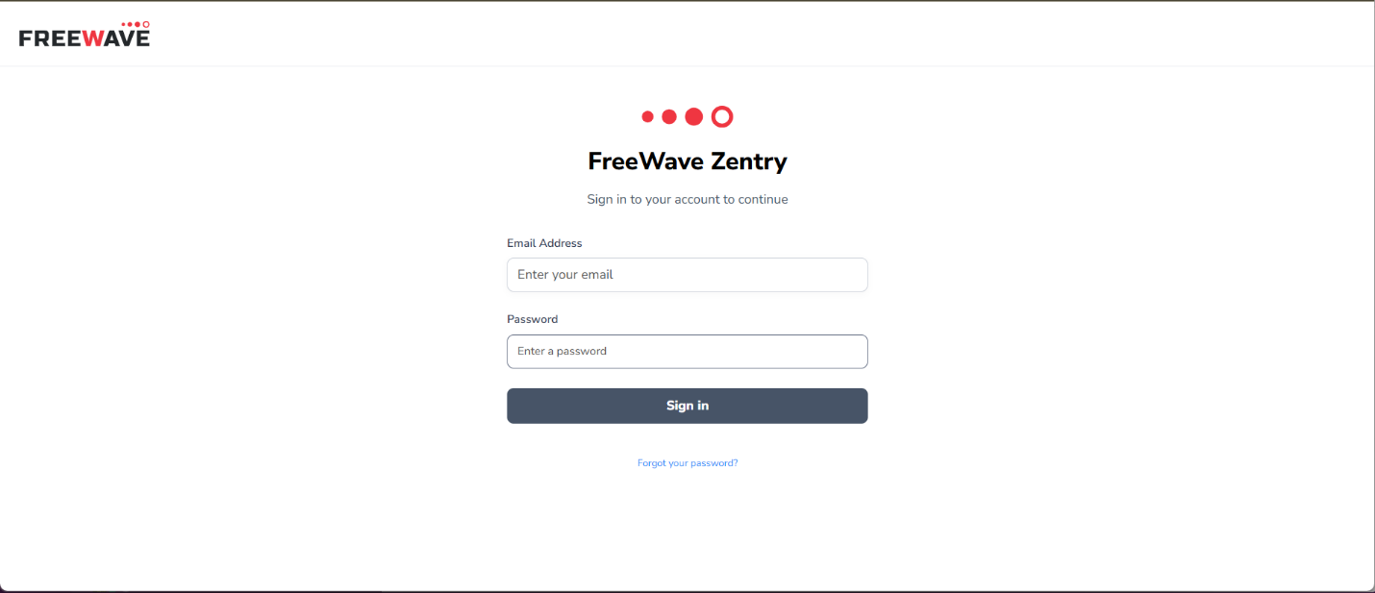
- Click the ES1000s tab on the left side navigation menu
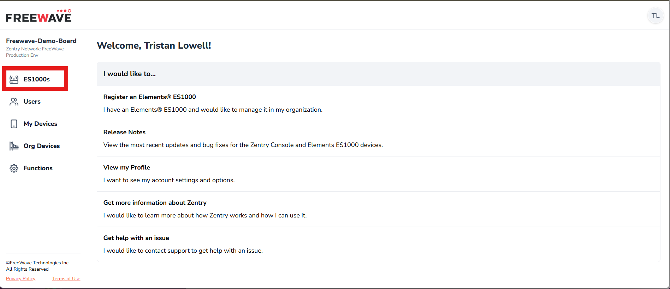
- Click “Claim an Elements ES1000”
  - Enter the claim token on the sticker attached to the ES1000 hardware unit.
  - Give the ES1000 a meaningful name
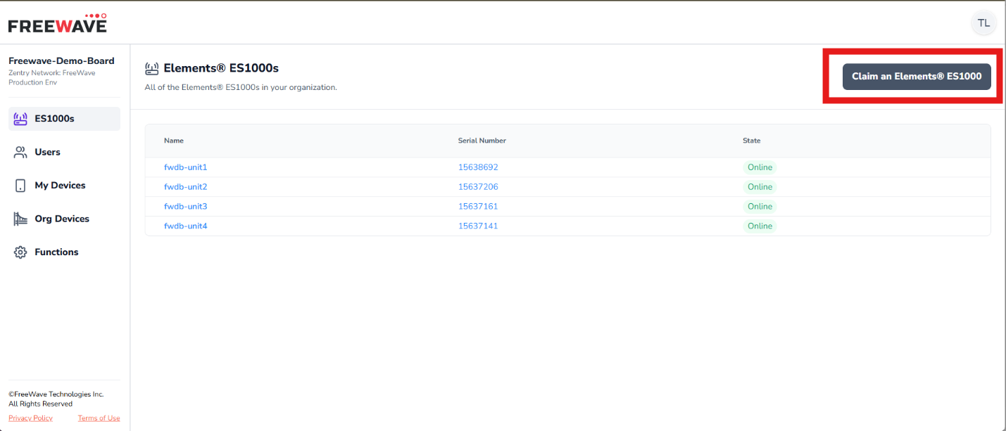
- Navigate back to the list of ES1000s
- Click the name of the ES1000 you just claimed.
- Click “View Zentry Identity”
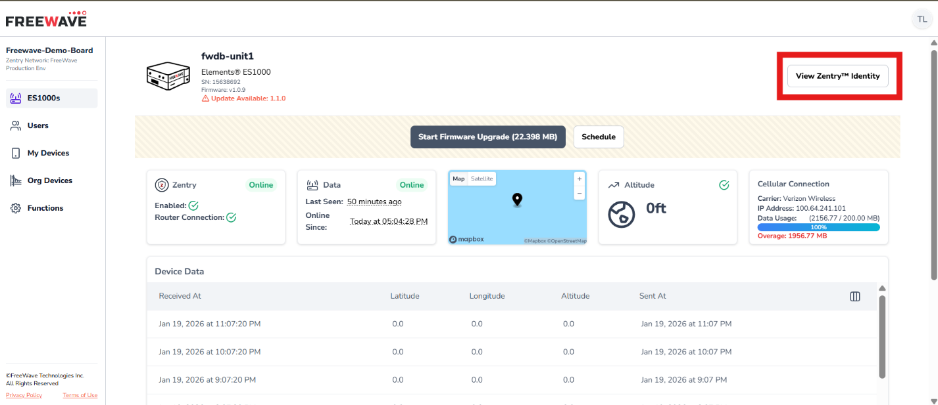
- Click “+ Host a Function on this Device”
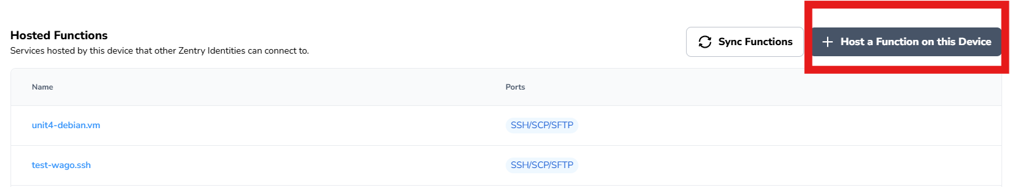
- Enter a function name
  - Ex: smt-node1.vnc
- Enter port 5900 into the “Additional Ports” section.
  - If the device dialing the function for accessing the SMT machine and there are more than one VNC session then you may need to add additional ports, 5901, 5902, etc. if trying to access multiple nodes at once. The ports tend to increment for every window opened in a VNC session.
- Enter the IP address of the host running the SMT software you are wanting to interact with remotely via the VNC session.
  - Ex:
    - Subnet of SMT network: 192.168.54.0/24
    - IP Address of Node1: 192.168.54.20
    - IP Address of Node2: 192.168.54.30
    - IP Address of ES1000: 192.168.54.1
  - If you want to reach Node1 you would enter the IP 192.168.54.20 into the Forward Host entry when creating the function.
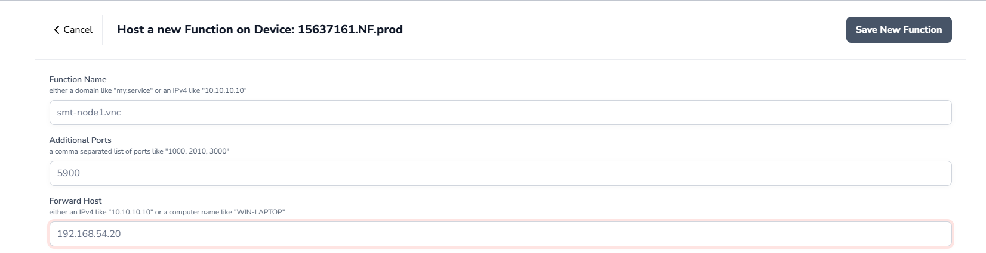
- Save the function.
- When viewing the list of functions hosted on the ES1000, select the function you just created
  - Example name: smt-node1.vnc
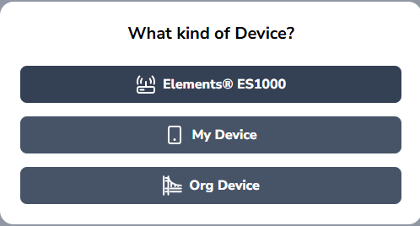
- Scroll down until you see the button “+ Add Identity to Function”
- Select the device group your device is defined under.
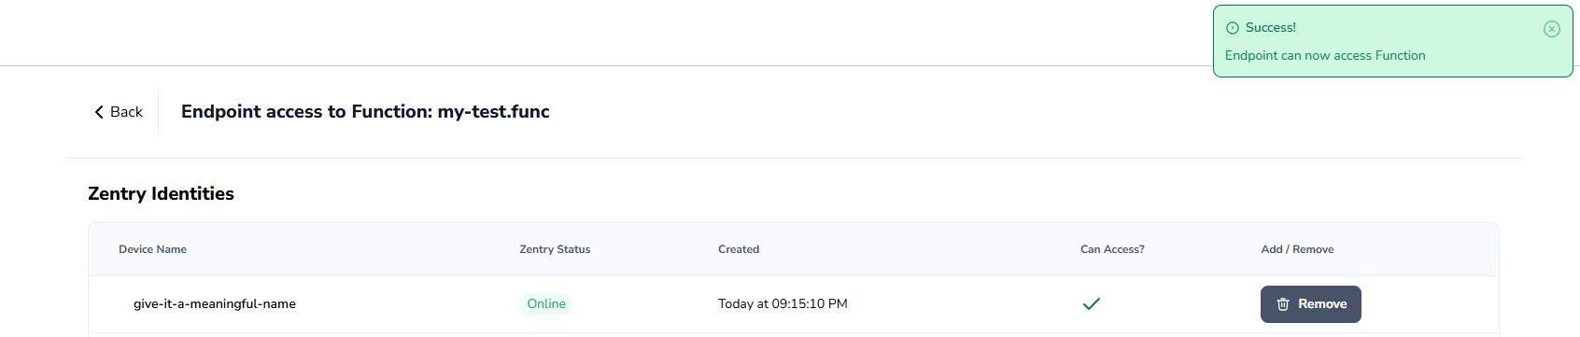
- Click the “Add” button in the right side of the row for the device you are granting permission to access the SMT node via the VNC software.
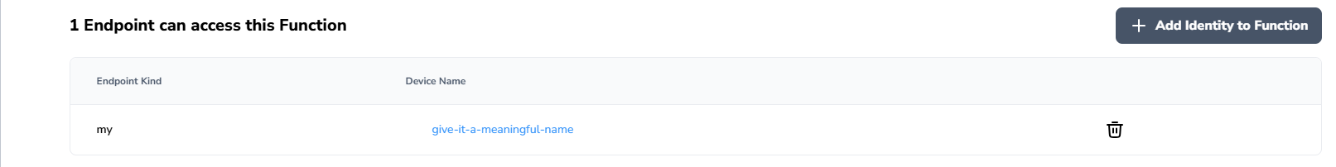
- Copy the function name
  - This function name will be entered into the VNC application.
- Now that all the Zentry pieces are set up, open the VNC software you prefer.
  - TightVNC will be used in this example.
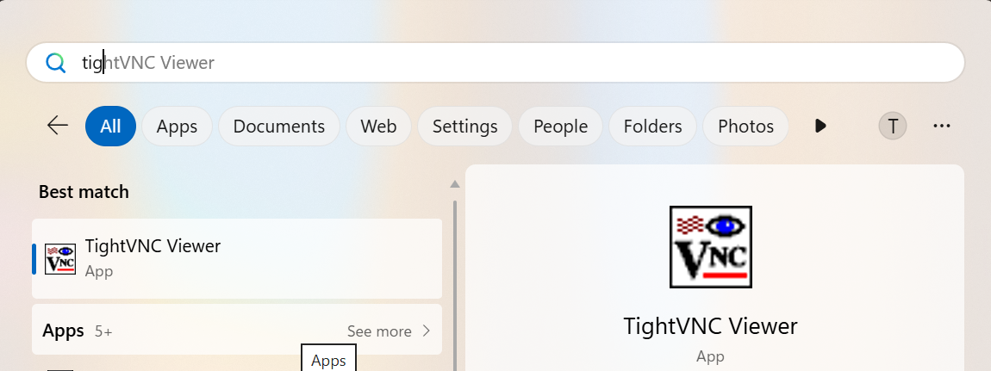
- Copy the Function name you created earlier
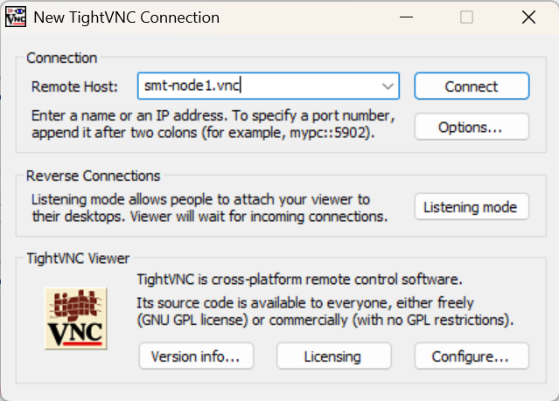
- Paste the copied Function name in the “Remote Host” box in the VNC application.
- Click Connect.

Installing TightVNC
- Navigate to: https://www.tightvnc.com/download.php
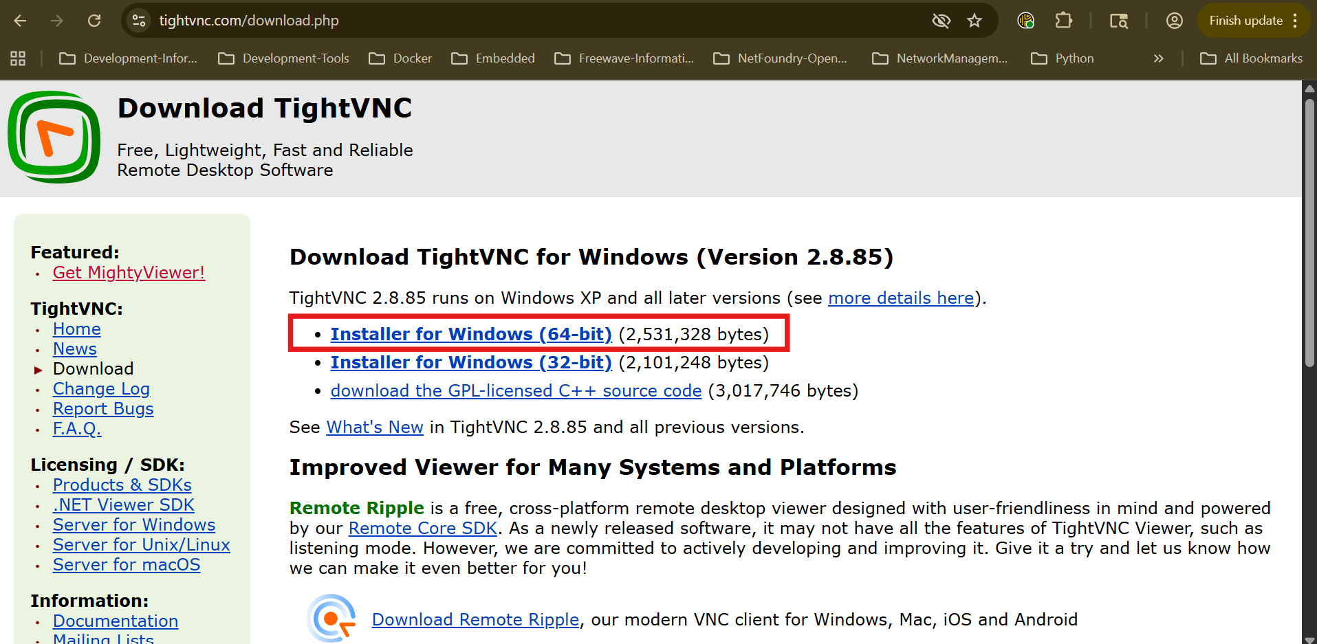
  - Check you OS specs and choose the appropriate installer.
    - Windows: System > About
      - Look for “System type” or something similar
- Download the Installer
- Navigate to install location and start installer.
  - Administrative privileges are needed to install TightVNC.
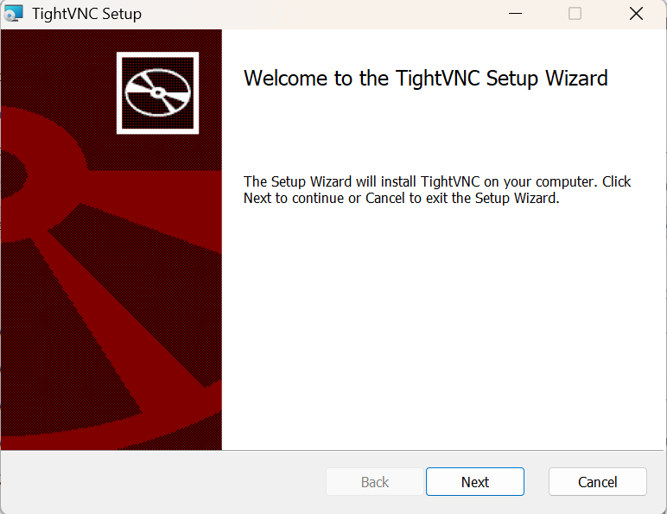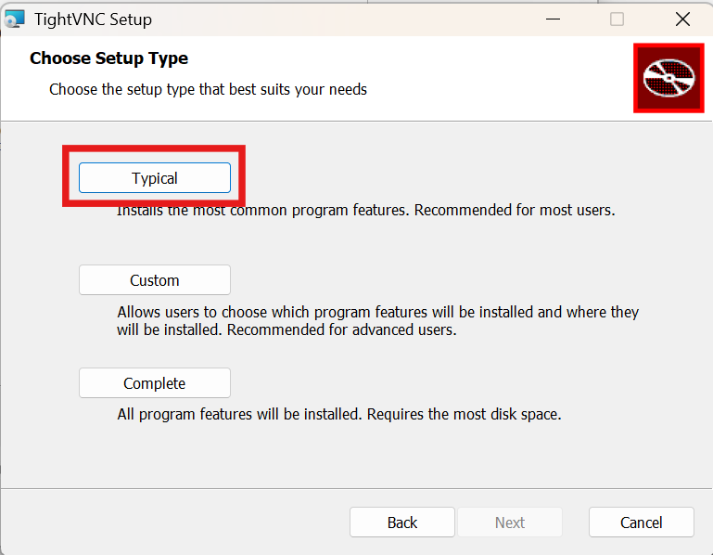
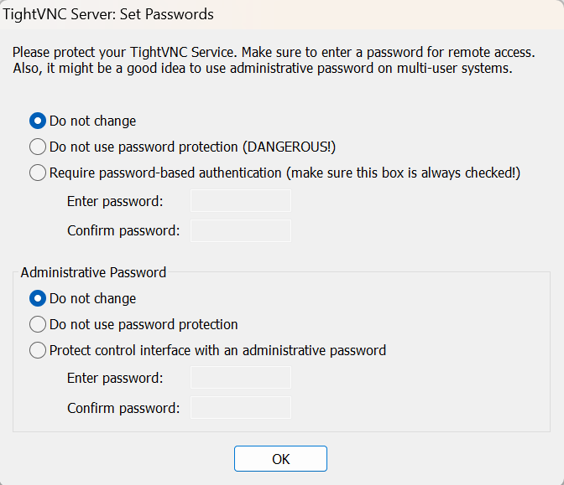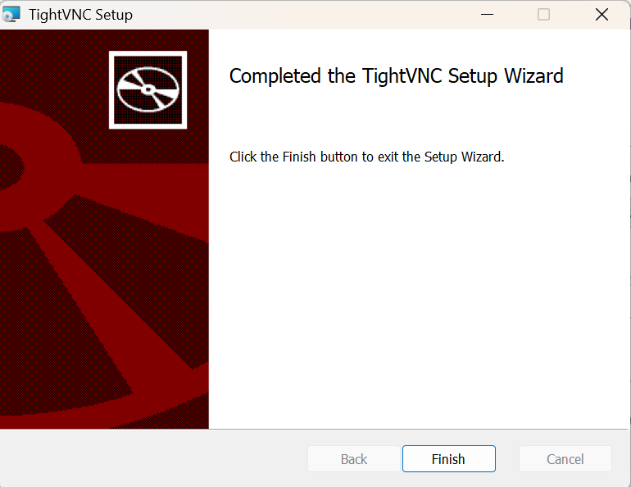
- Typical install is sufficient to complete this use case
- Choose the appropriate settings for “Set Passwords” portion of the installation.
- Click finish.

